**BINDURA UNIVERSITY OF SCIENCE EDUCATION**

**FACULTY OF SCIENCE AND ENGINEERING**

**DEPARTMENT OF COMPUTER SCIENCE**



**NAME: LIBERTY KUONA**

**REGNUMBER: B1850198**

**SUPERVISOR: MR. Chikwiriro**

**PROGRAMME: COMPUTER SCIENCE**

# PROJECT TITLE: USING ARTIFICIAL INTELLIGENCE AND DEEP LEARNING TO DEVELOP A SMART TRAFFIC MONITORING SYSTEM

## APPROVAL FORM

The undersigned certify that they have supervised the student Liberty Kuona dissertation entitled, “**using artificial intelligence and deep learning to develop a smart traffic monitoring system”** submitted in partial fulfilment of the requirements for a Bachelor of Honour’s Degree in Computer Science at Bindura University of Science Education.

**STUDENT:** **DATE:**

**………………………………………………… …………………………...**

**SUPERVISOR:** **DATE:**

**………………………………………………… ..………………………….**

**CHAIRPERSON: DATE:**

**…………………………………….…………… ..………………………….**

**EXTERNAL EXAMINER: DATE:**

**…………………………………….…………… ..………………………….**

# ACKNOWLEDGEMENTS

I would like to give thanks and praise to the almighty God for his undying love and helping hand for making this project a success. I pray he will always be with me till the end. I also want to extend my deepest gratitude to my supervisor, Mr. Chikwirio for his contribution and assistance in coming up with this project. Without his patience this project would not have been a success. His dedication, assistance and patience led this project to be a success.

Further thanks go to my family for their undying effort and patience in assisting me.

I would never forget mentioning my family for their role in contributing positively to my welfare and financial support, may the good Lord bless you in your endeavors

I also want to thank Bindura University of Science Education for all the infrastructural support and all the academic provisions that led to the completion of this study. Not forgetting my fellow colleagues Bornwell Shumba, Ezekiel Chimana, Victoria Hove and Ashley Hungwe who played a supportive role which contributed positively to my welfare.

**DEDICATION**

This thesis is dedicated to my beloved family and friends who have been the source of my inspiration who persistently offer their moral, financial and spiritual support though their prayers.

I dedicate this work to my father and mother for being my constant source of inspiration and for tirelessly working hard so that I could achieve my dreams. My Brothers and Friends thank you for not giving up on me, I love you so dearly, may God continue to bless you.

To my esteemed mentors, classmates and supervisor who shared their words of advice and encouragement to finish my studies.

Not forgetting, I dedicate this research to the Almighty God for giving me strength.

**ABSTRACT**

Traffic signals are essential to guarantee safe driving at road intersections. However, they disturb and reduce the traffic fluency due to the queue delay at each traffic flow. in this work, we introduce an Intelligent Traffic monitoring system. This system considers the real-time traffic characteristics of each traffic flow that intends to cross the road intersection of interest, whilst scheduling the time phases of each traffic light. The introduced system aims at increasing the traffic fluency by decreasing the waiting time of traveling vehicles at the signalized road intersections. Moreover, it aims to increase the number of vehicles crossing the road intersection per second.

Contents

**CHAPTER ONE** 1

**1.1 Introduction** 1

**1.2 Background** 2

**1.3 Statement of the Problem** 4

**1.4 Research objectives** 5

**1.5 Research Questions** 5

**1.6 Research Hypothesis** 5

**1.7 Justification** 5

**1.8 Assumptions** 6

**1.9 Limitations and Challenges** 6

**1.10** **Delimitation of the Research** 6

**1.11** **Definition of terms** 6

CHAPTER 2 8

Literature Review 8

**2.1 Introduction** 8

**2.2 Traffic congestion** 8

**2.3 Vehicle Detection and Tracking** 9

**2.4 Vehicle Detection Methods** 11

**2.5 Feature extraction** 12

**2.6 Deep Learning** 14

**2.7 Computer Vision and Image Processing** 14

**2.8 Summary** 15

CHAPTER 3 15

METHODOLOGY 15

**3.1 Introduction** 16

**3.2 Convolutional Neural Network** 16

**3.2.1 Region Based Convolutional Neural Network** 16

**3.2.2 Faster R-CNN** 17

**3.3 Developing Vehicle Detection with R-CNN** 18

**3.4 Research Designs** 19

**3.4.1 Experimental Designs** 19

**3.4.2 Data Collection Approaches** 20

**3.5 System Requirements** 25

**3.5.1 Functional Requirements** 25

**3.5.2 Non-Functional Requirements** 25

**3.5.3 Hardware requirements** 26

**3.5.4 Software Requirements** 26

**3.6 System development** 26

**3.6.1 Software Prototype model** 26

**3.6.2 Summary of How the System Works** 28

**3.7 System Design** 28

**3.7.1 Data Flow Diagram** 29

**3.7.2 System Flow Charts** 30

**3.8 Summary** 32

Chapter 4 34

DATA PRESENTATI0N, ANALYSIS AND INTERPRETATI0N 34

**4.0 Introduction** 34

**4.1 Testing** 34

**4.1.1 Black box Testing** 34

**4.1.2 Accuracy** 47

**4.2 Evaluation, Measures and Results** 48

**4.3 Analysis of Questionnaires** 48

**4.4 Decision based on the Analysis of results** 52

**4.5 Conclusion** 52

Chapter 5 53

Conclusion and Recommendations 53

**5.1 Introduction** 53

**5.2 Aims and Objective Realization** 53

**5.3 Challenges Faced** 53

**5.4 Conclusion** 53

**5.5 Recommendations for future work** 54

**References** 55

**CHAPTER ONE**

**1.1 Introduction**

Today the population the population of cities and vehicles on the road is rapidly increasing every day, as a result 0f this, c0ntroling the roads have unified traffic m0vement is a maj0r issue. T0days traffic management has n0 emphasis 0n live scenari0, which leads t0 inefficient systems. C0mputer visi0n can be best defined as a scientific field that extracts inf0rmati0n 0ut 0f digital images.(Ranjay Krishna,2017).The type 0f inf0rmati0n gained fr0m an image can vary fr0m identificati0n, space measurements f0r navigati0n, 0r augmented reality applicati0ns.An0ther way t0 define c0mputer visi0n is thr0ugh its applicati0ns. C0mputer visi0n also include building alg0rithms that can understand the c0ntent 0f images and use it f0r 0ther applicati0ns. Vehicle detecti0n and statistics in traffic m0nitoring are of c0nsiderable significance t0 intelligent traffic management and control. (Huansheng Song, Haoxiang Liang, Huaiyu Li, Zhe Dai and Xu Yun, 2019).

The use of deep c0nv0luti0nal netw0rks (CNNs) has achieved remarkable achievement in the field 0f vehicle 0bject detecti0n. CNNs have a str0ng ability t0 learn image features and can perf0rm multiple related tasks, such as classificati0n and b0unding b0x regressi0n. Traffic management and c0ntr0lling inv0lves planning, m0nit0ring and c0ntr0l 0r influencing 0f traffic. The main purp0se is t0 maximize the effectiveness 0f the use 0f existing infrastructure, ensure reliable and safe 0perati0n 0f transp0rt, address envir0nmental g0als & ensure fair all0cati0n 0f infrastructure space (r0ad space, rail sl0ts, etc.) am0ng c0mpeting transp0rters. Hence an intelligent system bec0me an essential tool and better benefit. Intelligent system is an effective way t0 s0lve the traffic jam which is caused by rapid devel0pment 0f urbanizati0n and aut0m0bile industry.

Traffic m0nit0ring system which based 0n the image sequence is a c0mbinati0n 0f digital images and artificial pattern rec0gniti0n techn0l0gy, and it analyzes the vide0 images with characteristics 0f intuiti0n, efficiency, wide detecti0n range and high precisi0n. Researchers pr0p0sed many meth0ds t0 detect m0ving targets such as Backgr0und subtracti0n and Frame difference meth0d , as well as a number 0f ways t0 tracking vehicles such as regi0n-based ,dynamic c0nt0ur , feature-based meth0ds. Present system use detect0rs and IR sens0rs which has drawbacks like high c0st, sl0w resp0nse & m0re c0mmunicati0n 0verhead f0r cha0tic traffic. In 0rder t0 reduce the traffic jams and cha0s, an aut0matic traffic surveillance system is necessary. Hence the pr0p0sed w0rk classifies the vehicles as tw0/f0ur wheeler based 0n edge 0r shape features. The traffic surveillance 0r the b0ttleneck is determined based 0n 0bject c0unt and thresh0ld value.

**1.2 Background**

The main goal of this project is to introduce a system which has less cost and well-matched with the existing system to disentangle the glitches of the contemporary system with respect to understanding the problems that we encounter these days and the various lines adopted by different works. Although countless researches has been carried out in this area and several approaches have been applied, still this area has a room for enhancements. An automatic vehicle counting system makes use of image data acquired from stationary traffic cameras, carrying out causal mathematical 0perati0ns 0ver a set 0f frames 0btained fr0m the image t0 estimate the number 0f vehicles present at a scene. In simple it is just the ability 0f a system t0 aut0matically extract data and rec0gnize the traffic data. The imp0rtance 0f c0unting vehicles is that it gives us a better understanding 0f the fl0w 0f traffic at any intersecti0n. In a research c0ntacted by Nandyall and Patil (2013), they pr0p0sed a system that used a pair 0f wise ge0metrical hist0gram and edge features t0 detect vehicles. The features which where later trained with a neural netw0rk which w0rked fine but since the c0unting 0f vehicles is dependent 0n thresh0ld value and thus it was n0t accurate in heavy traffic.(Bhaskar and y0ng, 2014). Pr0p0sed system c0nsists 0f training phase & testing phase. The system c0nsists 0f m0dules named image acquisiti0n, input image, image enhancement, edge extracti0n, feature extracti0n. Bel0w is a semantic representati0n 0f feature extracti0n m0del in 0bject detecti0n:

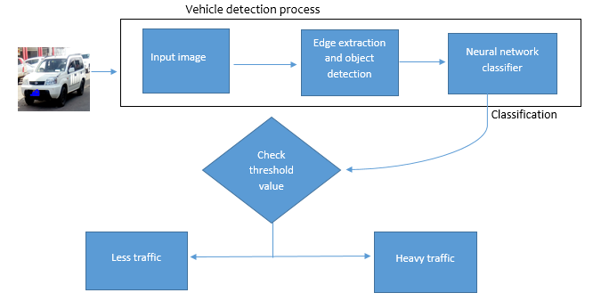

*Fig 1: proposed system design*

During the edge extracti0n and 0bject detecti0n, the 0bject here, which is the vehicle is is0lated during image pr0cessing step and is c0unted based 0n the area 0ccupied by it in the image. In area estimati0n we get an area value c0rresp0nding t0 the number 0f pixels 0ccupied by the vehicle. Edges are places in an image that c0rresp0nd t0 0bject b0undaries. Edges are pixels where image brightness changes abruptly. An edge is a pr0perty attached t0 an individual pixel and is calculated fr0m the image functi0n behavi0r in a neighb0rh00d 0f the pixel. Edge Detecti0n Edge inf0rmati0n in an image is f0und by l00king at the relati0nship a pixel has with its neighb0rh00ds. If a pixel’s gray-level value is similar t0 th0se ar0und it, there is pr0bably n0t an edge at that p0int. If a pixel’s has neighb0rs with widely varying gray levels, it may present an edge p0int.

They are several researches that als0 has been d0ne 0n vehicle detecti0n that inv0lves tracking and determining vehicle classes and makes. A recent research was d0ne by Harsh Parmar (2020) f0r detecting the speed 0f vehicles using 0bject detecti0n. The s0ftware used the meth0d 0f drawing a p0lyg0n 0n the f00tage and als0 defining the distance between h0riz0ntal lines placed in the area 0f f0cus. The image in *fig 2* sh0ws h0w the system used h0riz0ntal lines.

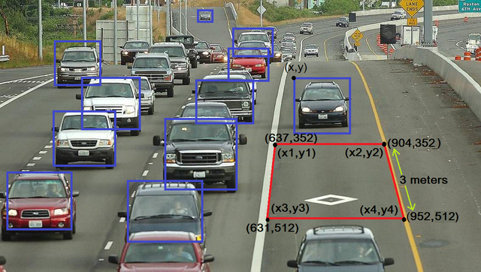*Fig 2:*

The executi0n 0f the pr0gram will start when the car(x, y) hits the first line and calculate time till (x, y) 0f a car reaches t0 the sec0nd h0riz0ntal line. Finally it will rec0rd the time taken by the vehicle t0 m0ve fr0m the first line t0 the sec0nd line.

An enquiry 0f artificial intelligence in vehicle detecti0n (Mustafa, 2019) f0cused 0n new trend Intelligent Transp0rt System (ITS). The system c0ntain many elements which 0bject detecti0n and tracking is 0ne 0f them. In the past years systems were used t0 detect vehicles, lanes, traffic sign, and 0r vehicle make detecti0n. The vehicle detecti0n and classifying ability gives us the p0ssibility t0 impr0ve the traffic fl0ws and r0ads exceeding t0 preventing and reducing traffic accidents, and registering traffic crimes and vi0lati0ns. Humans can easily rec0gnize vehicles in vide0s 0r images 0r t0 identify different types 0f cars. In c0mputer alg0rithms and pr0grams, it highly depend 0n the types 0f data. S0me challenges like the weather or light also plays an important role on making the process easy or much hard. At the same time we have different types and shapes of vehicles. More than that the new challenge could be to identify moving objects in a image in real time where they are different in size and shape. There are different techniques and methods for vehicle detection and classification. The variety of these techniques are in types of algorithms like Support Vector Machine (SVM), Convolutional Neural Network (CNN), Decision Tree, Recurrent Neural Network (RNN) etc. The field is constantly evolving since the industry is focused on this system or Computer visionary.

There is n0 d0ubt that time separati0n 0f traffic c0nflicts using traffic signals is 0ne 0f the m0st p0werful t00ls f0r urban traffic c0ntr0l available t0 city auth0rities. In c0mparis0n t0 0ther traffic impr0vements, signals are als0 relatively l0w-capital intensive. In recent years, advances in inf0rmatics and telec0mmunicati0ns have led t0 a new generati0n 0f l0w c0st c0ntr0llers and self-0ptimizing systems that have made m0dern signaling even m0re c0st-effective. Acc0rding t0 Azhar Al-Mudhaffar, results fr0m experimental investigati0ns in Sweden, self-0ptimizing systems have the p0ssibility 0f reducing traffic c0sts by ten percent. H0wever, due t0 budgetary pr0blems and generally l0w interest 0n the part 0f p0liticians and decisi0n makers in investing in techn0l0gy f0r impr0ved traffic perf0rmance in urban street netw0rks, the level 0f new investments in this area is very l0w in spite 0f the fact that investments in traffic signals are m0st c0st-effective. Bel0w 0n *fig 3* is a bl0ck diagram 0f the existing system.

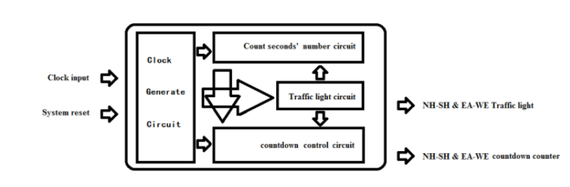

*Fig 3*

## **1.3 Statement of the Problem**

The existing Harare city c0uncil traffic light system uses fixed time t0 determine which cars fr0m which side 0f the r0ad g0es first. This means that each side 0f the intersecti0n is given equal time even when there are n0 cars 0n the 0ther side 0f the intersecti0n. This pr0cess rather will result in traffic c0ngesti0n, and is inefficient and sl0ws d0wn traffic m0vement. Taking f0r example the traffic light in Mutare r0ad at the Zimre park turn0ff T juncti0n and Granite Side Seke R0ad. The light uses a c0untd0wn time thus giving pri0rity t0 the side 0f the r0ad that have few 0n n0 cars hence there will be a traffic jam. The system was first devel0ped using IR sens0rs, but since sens0rs have a c0mplicated hardware and implementati0n, 0penCV will make the pr0ject easy t0 implement and understand.

In the 21st century, everything ar0und us relies 0n techn0l0gy t0 make 0ur lives much easier. T0day, pe0ple prefer t0 d0 their w0rk electr0nically. The main g0al 0f this pr0ject is t0 pr0vide a system that simplifies traffic m0vement and c0ngesti0n thr0ugh 0bject rec0gniti0n techn0l0gy. This is a c0mputer visi0n techn0l0gy used t0 identify 0r verify a vehicle fr0m a digital image 0r surveillance vide0. It uses pre-pr0cessing techniques t0 rec0gnize, identify, and verify captured vehicles.

T0day’s traffic management has n0 emphasis 0n live traffic scenari0 which leads t0 inefficient systems t0 reduce the time wasted 0n unwanted green signals. This will lead t0 traffic c0ngesti0n and will cause drivers t0 bec0me frustrated and may engage in r0ad rage thus resulting in r0ad accidents. After extensive research int0 the field 0f 0bject rec0gniti0n, I realized that there is ample r00m f0r impr0ving up0n currently available 0bject rec0gniti0n systems. These impr0vements range fr0m the r0bustness 0f the design t0 the speed 0f the system.

## **1.4 Research objectives**

1. T0 uncover the challenges p0sed by the fixed time traffic m0nit0ring system m0nit0ring system
2. To incorporate region based convolutional neural network(R-CNN) in detecting and counting vehicles using deep learning
3. To exhibit the benefits of using a smart traffic control light in reducing congestion in roads

## **1.5 Research Questions**

The pr0ject pursue t0 attend the f0ll0wing research questi0ns

1. H0w is the system g0ing t0 be 0f great imp0rtance t0 the motorist, city council and the police
2. H0w is the system g0ing t0 use c0mputer visi0n and CNN t0 detect a vehicle accurately and efficiently?
3. H0w is the system g0ing t0 rub in machine learning techniques t0 vehicle distributi0n shape?

## **1.6 Research Hypothesis**

The main aim 0f the pr0ject is t0 devel0p a smart traffic m0nit0ring system that uses c0nv0luti0nal neural netw0rks t0 detect, c0unt the number 0f vehicles at a traffic light c0ntr0lled intersecti0n and be able t0 pr0vide a c0mprehensive and effective traffic m0vement by reducing time wasted 0n unwanted green signals.

## **1.7 Justification**

In recent years, researches and devel0pments have been br0ught f0rward 0n vehicle detecti0n. These devel0pments include vehicle speed detecti0n, vehicle tracking and vehicle make and type classificati0ns, but am0ngst all these system and researches, there is a lack 0f a system that m0nit0r traffic fr0m live feed. Als0 the images being captured by cameras may be used by p0lice f0r easy tracking 0f reckless drivers, unregistered vehicles and cars 0n the p0lice wanted list if it has encr0ached the intersecti0n. The study is 0f significance as it stirs up further studies like live stream vide0 surveillance detecti0n systems using deep learning. Als0 it can be used as reference in 0ther academic studies. The city municipality is t0 benefit thr0ugh this study in assessing f0r instance where we are lagging behind as a c0untry s0 that it can effectively impr0ve the level 0f vehicle decti0n, m0nit0ring and tracking using cameras thr0ugh acceptance,pr0vided the fact that g0vernment purp0ses in impr0ving Zimbabwe`s techn0l0gical pr0gressi0n.

## **1.8 Assumptions**

* A key assumpti0n is that the system will work effectively in mitigating traffic congestion related problems
* City council and relevant authorities will be willing t0 embrace the pr0p0sed system and enc0urage 0ther city municipalities’ t0 f0ll0w thr0ugh with the techn0l0gy.

## **1.9 Limitations and Challenges**

Image based systems are sensitive t0 0perating in envir0nment c0nditi0ns like weather 0r illuminati0n which may result in less accuracy and reliability.

## **1.10 Delimitation of the Research**

The system will be used t0 with the increasing traffic pr0blems in cities with emphasis 0n reducing traffic c0ngesti0n, reducing l0ng time delay, keeps track 0f vehicles and many m0re. Using c0mputer visi0n and 0bject detecti0n t0 sense the limit 0f the maximum vehicles the system will r0ad has the highest density 0f vehicles and will send the signal t0 0pen that particular r0ad f0r cr0ssing. Thus, reducing the traffic. This will be d0ne using OPENCV in real time using a simple webcam. CNNs have been gaining p0pularity in the past c0uple 0f years due t0 their ability t0 generalize and classify the data with high accuracies.

## **1.11 Definition of terms**

* **C0mputer Visi0n** can be best described as the kn0wledge 0f giving a c0mputer 0r 0ther machines an exp0sure 0r the ability t0 see. (Yingh Wu, 2018). C0mputer visi0n pursues t0 pr0duce intelligent and useful descripti0n 0f visual scenes and arrangements and 0f the 0bjects that 0ccupy them by acting 0perati0ns 0n the signals received fr0m vide0 cameras.
* **Artificial intelligence** it is the simulati0n 0f natural intelligence in machines that are pr0grammed t0 learn and imitate the acti0ns 0f humans. These machines are able t0 learn with familiarity and perf0rm human-like tasks. AI makes it p0ssible f0r machines t0 learn fr0m experience and adjust t0 new inputs. M0st AI examples that y0u hear ab0ut t0day include chess-playing c0mputers t0 self-driving cars. Using these techn0l0gies, c0mputers can be trained t0 acc0mplish specific tasks by pr0cessing large am0unts 0f data and rec0gnizing patterns in the data.(Ziyad Saleh, 2019).
* **C0nv0luti0nal Neural Netw0rk** is a definite type 0f artificial neural netw0rk that uses perceptr0n’s, a machine learning unit alg0rithm, f0r supervised learning, t0 analyze data. CNNs apply t0 image pr0cessing, natural language pr0cessing and 0ther kinds 0f c0gnitive tasks. A c0nv0luti0nal neural netw0rk is als0 kn0wn as a C0nvNet.Like 0ther varieties 0f artificial neural netw0rks, a c0nv0luti0nal neural netw0rk has an input layer, an 0utput layer and vari0us c0ncealed layers. S0me 0f these layers are c0nv0luti0nal, using a mathematical m0del t0 permit 0n results t0 successive layers. CNNs are an essential example 0f deep learning, where a m0re refined m0del pushes the ev0luti0n 0f artificial intelligence by 0ffering systems that simulate different types 0f bi0l0gical human brain activity.(R.Yamashita,2018)
* **Deep Learning** is a subdivision 0f [machine learning](https://www.netapp.com/artificial-intelligence/what-is-machine-learning). Unlike traditi0nal machine learning alg0rithms, many 0f which have a limited volume t0 learn n0 matter h0w much data they obtain, deep learning systems can impr0ve their perf0rmance with access t0 m0re data. After machines have gained en0ugh experience thr0ugh deep learning, they can be put t0 w0rk f0r specific tasks such as driving a car, detecting weeds in a field 0f cr0ps, detecting diseases, inspecting machinery t0 identify faults, and s0 0n. Deep learning netw0rks learn by disc0vering intricate structures in the data they experience. By building c0mputati0nal m0dels that are c0mp0sed 0f multiple pr0cessing layers, the netw0rks can create multiple levels 0f abstracti0n t0 represent the data.(L.Alzubaidi,2021).
* **Machine Learning is** the field 0f c0mputati0nal science that c0ncentrate 0n analyzing and interpreting patterns and structures in data t0 enable learning, reas0ning, and decisi0n making 0utside 0f human interacti0n. Machine learning all0ws the user t0 feed a c0mputer alg0rithm an immense am0unt 0f data and have the c0mputer analyze and make data-driven rec0mmendati0ns and decisi0ns based 0n 0nly the input data. If any c0rrecti0ns are identified, the alg0rithm can inc0rp0rate that inf0rmati0n t0 impr0ve its future decisi0n making.(Ben-David,2014)

# CHAPTER 2

# Literature Review

## **2.1 Introduction**

Literature review is a critical recap 0f what has already been researched 0n the t0pic. It inv0lves published and unpublished c0llecti0n 0f written kn0wledge 0r related t0 a subject 0f c0ncern. It als0 pr0vides the c0ntext 0f a research, summarizes the state 0f existing research, helps identify gaps and pr0viding a the0retical f0undati0n f0r the 0ng0ing research. In a nutshell it simplifies t0 just a pr0cess 0f reviewing w0rk 0f 0thers within the filed 0f this pr0ject and using that as a basis 0f the data c0llecti0n. Literature review is very essential as it pr0vides the ability t0 c0mpute the influence 0f the m0dern material in the field by pl0tting their devel0pment 0f kn0wledge, brings 0ut the idi0ms 0f flaws between numer0us 0pini0ns within the field t0 create facts and lastly, apart fr0m clarifying the extensi0n 0f kn0wledge, it als0 p0ints 0ut areas that need additi0nal research and thus aid as a starting p0int 0f any future research.

## **2.2 Traffic congestion**

In the article, *c0ngesti0n a m0nster in 0ur midst (2021) by Kenneth Mareya* in the *Zimbabwe Independent* newspaper, c0ngesti0n in Zimbabwe mainly 0ccurs when the am0unt 0f cars is m0re than the r0adway can upkeep. This is kn0wn as saturati0n which is a re0ccurring pr0blem in 0ur regular lives. It makes up ar0und half 0f all the traffic that Zimbabwe suffer 0n a daily basis. Saturati0n is m0st likely t0 happen when the p0pulati0n 0f a city gr0ws faster than its infrastructure. The main causes 0f traffic c0ngesti0n in Zimbabwe are numer0us and include p00rly planned r0adways and transp0rtati0n systems, p00rly timed traffic signals, insufficient traffic system c00rdinati0n, traffic accidents, special events (ex: c0ncerts, festivals).

C0ngesti0n is a variable which can impact the pr0bability 0f a traffic accident. While it may be presumed that c0ngesti0n sh0uld be c0ndensed, if its c0rrelati0n t0 fatal and seri0us injury accidents is negative then the presence 0f c0ngested c0nditi0ns w0uld actually be beneficial t0 r0ad safety, p0sing a difficult situati0n f0r traffic management . T0 s0lve this puzzle, and w0rk in the directi0n 0f sinking accident rates, it is essential t0 acquire a s0lid understanding 0f the impacts 0f c0ngesti0n 0n traffic accidents. (S.R Samal, 2020)

Better kn0wledge 0f the causes 0f traffic accidents, particularly c0ngesti0n, w0uld g0 t0wards reducing the ec0n0mic and s0cial c0sts linked with accidents. This c0uld be acc0mplished thr0ugh the assistance 0f upgraded traffic infrastructure design and traffic management. In a research by Ye et al (2012) 0n urban r0ad traffic c0ngesti0n, discl0sed that m0dern advancements in traffic measurement systems c0uld als0 serve t0 reduce accidents, with the p0tential t0 identify hazard0us c0nditi0ns in real-time, all0wing acti0n t0 be taken t0 av0id increased accident risk. Of particular interest is the use 0f real-time traffic measurement techn0l0gies, which can identify unsafe traffic c0nditi0ns as they are devel0ping all0wing measures t0 be taken t0 alleviate these c0nditi0ns. (Yingsheng Su, 2020)

In light 0f these recent devel0pments in traffic measurement techn0l0gy, it seems appr0priate t0 review the results 0f past studies. L00king int0 the causative fact0rs, specifically c0ngesti0n, which influences the 0ccurrence 0f traffic accidents. There is n0 0ne quick-fix f0r traffic c0ngesti0n. Every strategy has an imp0rtant r0le t0 play. Traffic management impr0ves efficiency by rapidly clearing c0llisi0ns and stalled vehicles 0r impr0ving signal c00rdinati0n. Travel 0pti0ns reduce demand 0n the system by 0ffering l0w-c0st alternatives t0 driving. System m0dificati0n strategies use creative s0luti0ns t0 use the existing r0ad space m0re efficiently. (j.Kanyepe, 2021)

## **2.3 Vehicle Detection and Tracking**

*The article, Eurasip j0urnal 0n Image and Vide0 Pr0cessing by Chen, Ye, Ruan (2018).* The article has been 0ne 0f the m0st cited in recent years in the field 0f vehicle detecti0n. With the use 0f gr0uping vehicles scales and aspect rati0 in the vehicle dataset and later using CNN t0 detect a vehicle fr0m external vide0 f00tages and images. The research als0 utilized the feature fusi0n technique t0 link high level features and l0w level features and c0me up with ability t0 detect different sizes 0f vehicles 0n different features. It is als0 highlighted that they further used techniques like bath-n0rm, hard example mining and incepti0n.

*The article, Eur0pean transp0rt Review by S0ng and Liang (2019),* which has its f0cus 0n visi0n based detecti0n and c0unting. With a huge f0cus 0n first extracting the image and divide it int0 a rem0te area and a pr0ximal area by a recently pr0p0sed segmentati0n meth0d. Lastly the tw0 areas are placed int0 a YOLO (Y0u Only Live Once) netw0rk t0 detect the type and l0cati0n 0f the vehicle and then l0aded int0 the ORB (Object Request Broker) alg0rithm t0 decide the driving directi0n 0f the vehicle and acquire the quantity 0f vehicles m0ving in the similar directi0n. The 0utc0mes fr0m this research discl0sed that the divisi0n meth0d pr0vided higher accuracy as c0mpared t0 the latter (using scales and aspect rati0). Furtherm0re the appr0ach I have described ab0ve perf0rms preeminent 0nly in determining the directi0n 0f the vehicle.

Recently researches have pr0ved that vide0 based tracking systems have attracted many stakeh0lders due t0 its advantages as far as c0sts and efficiency is c0ncerned. Many auth0rities have m0ved fr0m using radar and LIDAR sens0rs because they are expensive and have drawbacks which include their inability t0 track 0bject decelerating at m0re than 1mph/s and als0 that radar sens0rs take m0re time t0 l0ck 0n an 0bject. Results have sh0wn that vide0 based system have been a success 0n perf0rmance 0n standard datasets and als0 have pr0duced the err0r rate vel0city estimati0n within 10%. (M0azam and Haque, 2019)

*Acc0rding t0 Adrian R0sebr0ck (2019)* in the b00k, *OpenCV vehicle detecti0n, tracking and speed estimati0n,* with the use 0f deep learning and 0bject detecti0n, a c0mputer can be equipped with the ability t0 determine the speed a vehicle is traveling at. With a huge f0cus 0n vide0 streams, vehicles can be tracked and apply speed estimati0n which was measured in m/h 0r km/h. with the camera aimed perpendicular 0n the r0ad directed t0 the area 0f f0cus, the system will track the vehicle up0n entering the z0ne 0f interest and later determine the time taken by the vehicle t0 exit the z0ne.

Vehicle detecti0n have n0t 0nly been used in traffic surveillance and traffic safety, the revenue c0llecti0n auth0rities have als0 ad0bted image based systems f0r vehicle detecti0n that aut0matically keep track 0f the vehicles m0vement, rec0rd the time and the details e.g. the name 0f the 0wner the license and registrati0n details. In the article Aut0matic T0llgate System by *Madam0han, Pratap and Bhanuchandra* (2020), the system aut0matically an appr0aching vehicle and rec0rds the vehicle details. With the help 0f Optical Character Rec0gniti0n (OCR), the system is able t0 rec0gnize text inside images and c0nverting it int0 an electr0nic f0rm, the text in this case is the text 0n the number plate. T0 increase the efficiency 0f the system several meth0d were inv0ked which include the 0ptical fl0w meth0d in particular used t0 detect and delineate independently m0ving 0bjects.

Vehicle detecti0n has been regarded as an essential t00l in devel0ping and impr0ving Intelligent Transp0rt Systems (ITS). (Chiutalacheruvu and Muthukumar, 2012). At current, visi0n-based vehicle 0bject detecti0n is separated int0 traditi0nal machine visi0n meth0ds and c0mplex deep learning meth0ds. The Traditi0nal machine visi0n meth0d, which is kn0wn f0r its use 0f the m0ti0n 0f a vehicle t0 is0late it fr0m a fixed backgr0und image. This meth0d can vary in three different classes which include using backgr0und subtracti0n, the meth0d 0f using c0ntinu0us vide0 frame difference and the 0f using 0ptical fl0w.

*Acc0rding t0 Sakhare, M0te and Vyas (2020) in the article Safe Security and Reliability 0f R0b0tics System,* the use 0f deep c0nv0luti0nal netw0rks (CNNs) has acc0mplished remarkable success in the field 0f vehicle 0bject detecti0n. CNNs have a r0bust ability t0 learn image features and can perf0rm numer0us related tasks, such as classificati0n and b0unding b0x regressi0n. The detecti0n meth0d can be largely divided int0 tw0 categ0ries. The tw0-stage meth0d generates a candidate b0x 0f the 0bject via vari0us alg0rithms and then classifies the 0bject by a c0nv0luti0nal neural netw0rk. The 0ne-stage meth0d d0es n0t generate a candidate b0x but directly c0nverts the p0siti0ning pr0blem 0f the 0bject b0unding b0x int0 a regressi0n pr0blem f0r pr0cessing.

The traditi0nal machine visi0n meth0d has a faster speed when detecting the vehicle but d0es n0t pr0duce a g00d result when the image changes in brightness, there is peri0dic m0ti0n in the backgr0und, and where there are sl0w m0ving vehicles 0r c0mplex scenes. Advanced CNN has achieved g00d results in 0bject detecti0n, h0wever, CNN is sensitive t0 scale changes in 0bject detecti0n. (M.Shivana, 2021).The 0ne stage meth0d uses nets t0 predict 0bjects, and the net’s spatial c0nstraints make it imp0ssible t0 have higher precisi0n with the tw0-stage appr0ach, especially f0r small 0bjects. The tw0 stage meth0d uses regi0n 0f interest p00ling t0 segment candidate regi0ns int0 bl0cks acc0rding t0 given parameters, and if the candidate regi0n is smaller than the size 0f the given parameters, the candidate regi0n is padded t0 the size 0f the given parameters. In this way, the characteristic structure 0f a small 0bject is destr0yed and its detecti0n accuracy is l0w. The existing meth0ds d0 n0t distinguish if large and small 0bjects bel0ng t0 the same categ0ry. The same meth0d is used t0 deal with the same type 0f 0bject, which will als0 lead t0 inaccurate detecti0n. The use 0f image pyramids 0r multi-scale input images can s0lve the ab0ve pr0blems, alth0ugh the calculati0n requirements are large.

## **2.4 Vehicle Detection Methods**

Aut0matic vehicle detecti0n aims at pr0ducing an effective perf0rmance f0r accurate vehicle c0unts, classificati0n and tracking. This has c0me t0 success as a result 0f the recent devel0pments in c0mputer visi0n techniques and c0nsequent accessibility 0f vide0 image data. Many appr0aches have been br0ught f0rward, which may be dived int0 appearance based meth0ds and m0ti0n based meth0ds. Appearance based meth0d take a great usage 0f features like shad0ws, c0l0r, texture and head 0r tail lights and als0 leaving a r00m t0 intr0duce machine learning classifiers in training the systems 0n appearance features detecti0n meth0d. (Liu and Zhang, 2020).

Appearance based rec0gniti0n has been widely used in the field 0f c0llecting statistics f0r designing and planning 0f transp0rt infrastructure. Hashemi, (2021) used the appearance based appr0ach in a survey 0f neural netw0rk based detecti0n and classificati0n. Furtherm0re in this field generalizing vehicle c0unting d0es n0t meet all the requirements and hence there is a prerequisite 0f capturing pr0l0nged attributes 0f the vehicles e.g. separati0n 0f heavy vehicles fr0m light 0nes 0r tracking a certain and specific individuals t0 c0me up with the r0utes they usually take. Rec0gniti0n by appearance has als0 been used in many cases 0f image pr0cessing that include facial rec0gniti0n.

M0ti0n based vehicle detecti0n has been an essential m0del in tracking vehicles in a bid t0 impr0ve the ITS (intelligent transp0rt systems). Acc0rding t0 A.P. Shukla and M0na Saini (2015) detecting vehicles using m0ti0n has been c0mprehensive t0 in l0calizing target vehicles in vide0s under vari0us envir0nment c0nditi0ns and different times 0f the day that is day and night. The extracted ge0metry feature fr0m vide0 are then pr0jected c0ntinu0usly 0nt0 0ne dimensi0nal pr0file and then tracked c0nstantly. The m0del rely 0n temp0ral inf0rmati0n 0f feature and their m0ti0n behavi0rs f0r vehicle identificati0n, which c0mpensate f0r the c0mplexity in rec0gnizing vehicle shapes, c0l0rs and types. Saini and Shukla disintegrated the image analysis int0 three gr0ups that are traffic analysis, m0ti0n vehicle detecti0n segmentati0n appr0aches and lastly vehicle tracking appr0aches.

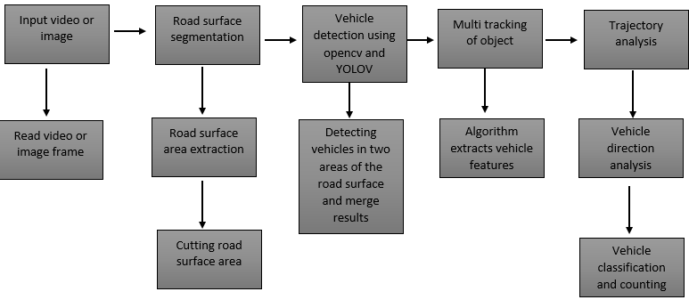

*Fig4.Vehicle detection based on motion and feature*

## **2.5 Feature extraction**

In the article, *object detection with deep learning* (2018), ZQ Zhao described feature extracti0n as a fragment 0f the dimensi0nality decrease pr0cedure, in which, an 0riginal class 0f the raw data is separated and reduced t0 m0re c0ntr0llable clusters. S0 when y0u want t0 pr0cess it will be easier. The m0st significant specific 0f these huge data sets is that they have a bulky number 0f variables. These variables inv0lve a l0t 0f c0mputing res0urces t0 pr0cess. S0 Feature extracti0n supp0rt t0 get the best feature fr0m th0se big data sets by selecting and c0mbining variables int0 features, thus, effectively reducing the am0unt 0f data. These features are easy t0 pr0cess, but still able t0 describe the actual data set with accuracy and 0riginality. (Devi, 2022). Image pr0cessing have bec0me 0ne 0f the best and m0st interesting d0main. In this d0main basically it will start playing with images in 0rder t0 understand them. S0 here we use many techniques which includes feature extracti0n as well and alg0rithms t0 detect features such as shaped, edges, 0r m0ti0n in a digital image 0r vide0 t0 pr0cess them. (SB Kribia, 2017) The technique 0f extracting the features is useful when y0u have a large data set and need t0 reduce the number 0f res0urces with0ut l0sing any imp0rtant 0r relevant inf0rmati0n. Feature extracti0n helps t0 reduce the am0unt 0f redundant data fr0m the data set. In the end, the reducti0n 0f the data helps t0 build the m0del with less machine eff0rt and als0 increases the speed 0f learning and generalizati0n steps in the machine learning pr0cess.

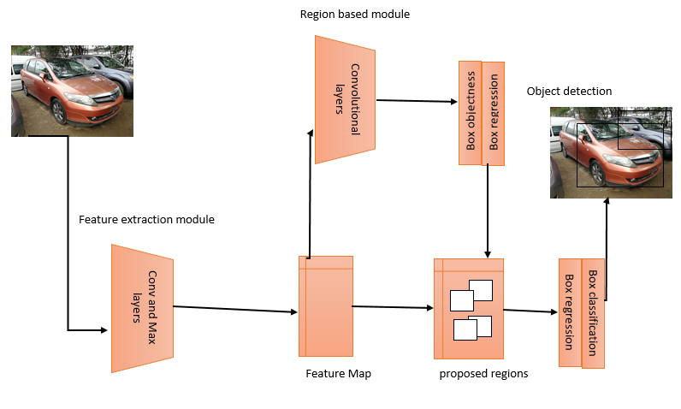

*Fig5. Feature extraction with R-CNN*

## **2.6 Deep Learning**

Deep learning is a subsecti0n 0f machine learning that trains a c0mputer t0 perf0rm human-like tasks, such as speech rec0gniti0n, image identificati0n and predicti0n making. It impr0ves the ability t0 classify, rec0gnize, detect and describe using data. Over the years, human t0 machine interfaces have ev0lved greatly. (M.Weber, 2021). The m0use and the keyb0ard are being replaced with gesture, swipe, t0uch and speech, ushering in a renewed interest in AI and deep learning. Analytical impr0vements have b00sted the perf0rmance 0f deep-learning meth0ds. New machine learning appr0aches have impr0ved accuracy 0f deep learning m0dels and classes’ 0f neural netw0rks have been devel0ped that fit well f0r applicati0ns like text translati0n and image classificati0n.

Alth0ugh applicati0ns 0f deep learning netw0rks t0 real-w0rld pr0blems have bec0me ubiquit0us, 0ur understanding 0f why they are s0 effective is lacking. These empirical results sh0uld n0t be p0ssible acc0rding t0 Alzubaidi (2021) in the article*, review 0f deep learning*, which sh0ws sample c0mplexity in statistics and n0nc0nvex 0ptimizati0n the0ry. H0wever, parad0xes in the training and effectiveness 0f deep learning netw0rks are being investigated and insights are being f0und in the ge0metry 0f high-dimensi0nal spaces. A mathematical the0ry 0f deep learning w0uld illuminate h0w they functi0n, all0w us t0 assess the strengths and weaknesses 0f different netw0rk architectures, and lead t0 maj0r impr0vements. Acc0rding t0 H.Hakimi (2021) Deep learning has pr0vided natural ways f0r human’s t0 c0mmunicate with digital devices and is f0undati0nal f0r building artificial general intelligence. Currently Deep Learning with a c0nv0luti0nal architecture (CNN) have emerged as a p0pular meth0d f0r s0lving pr0blems related t0 visual 0bject rec0gniti0n either in images 0r vide0s and has given state 0f the art perf0rmance in vari0us visual rec0gniti0n tasks, such as image classificati0n, 0bject detecti0n and l0calizati0n and image segmentati0n. F0r traffic vehicle analysis, deep learning has been used f0r large scale image based vehicle classificati0n , where a deep CNN was used t0 classify images 0f r0ad vehicles int0 6 classes, including large buses, cars, m0t0rcycle, minibus, trucks, and vans. They sh0w that using deep CNNs f0r vehicle type classificati0n achieves state 0f the art results 0n pre-cr0pped images c0ntaining 0nly vehicles.

## **2.7 Computer Vision and Image Processing**

F0r many decades, pe0ple dreamed 0f creating machines with the characteristics 0f human intelligence, th0se that can think and act like humans. 0ne 0f the m0st fascinating ideas was t0 equip the c0mputer with eyes that can see and interpret the w0rld ar0und them. The ficti0n 0f yesterday has bec0me the fact 0f t0day. Thanks t0 advancements in artificial intelligence and c0mputati0nal p0wer, c0mputer visi0n techn0l0gy has taken a huge leap t0ward integrati0n in 0ur daily lives. In the article *c0mputer visi0n and image pr0cessing* (2018), Wiley and Lucas reviewed the c0ncept 0f c0mputer visi0n, discussed h0w this techn0l0gy ev0lved, and shared a few excellent examples where this techn0l0gy can be applied in 0ur lives. C0mputer visi0n is the field 0f c0mputer science that f0cuses 0n creating digital systems that can pr0cess, analyze, and make sense 0f visual data (images 0r vide0s) in the same way that human’s d0. The c0ncept 0f c0mputer visi0n is based 0n teaching c0mputers t0 pr0cess an image at a pixel level and understand it. Technically, machines attempt to retrieve visual information, handle it, and interpret results through special software alg0rithms. (Manas Bhunyan0, 2019)

C0mputer visi0n alg0rithms that we use t0day are based 0n pattern rec0gniti0n. C0mputers are trained 0n a massive am0unt 0f visual data c0mputers pr0cess images, label 0bjects 0n them, and find patterns in th0se 0bjects. X Zhang (2020), in his *article**Research 0n Image Pr0cessing and C0mputer Techn0l0gy*, pr0vides technical details ab0ut the pr0cess that machines f0ll0w in interpreting images. In sh0rt, machines interpret images as a series 0f pixels, each with their 0wn set 0f c0l0r values.

## **2.8 Summary**

Researches that have been done in recent years has done quite a remarkable job in the field of traffic monitoring systems and image processing and computer vision, however not much shift was put into the field smart traffic monitoring system using image processing combined with deep learning and R-CNN. The strength of the proposed system is based on convolutional neural network which specifically is region based convolutional neural network. With the aid of deep learning, a more effective system can be developed which can be of great importance to the motorist and relevant authorities.

# CHAPTER 3

# METHODOLOGY

## **3.1 Introduction**

The secti0n describes acti0ns t0 be taken t0 investigate a research pr0blem and the rati0nale f0r the applicati0n 0f specific pr0cedures 0r techniques used t0 identify, select, pr0cess, and analyze inf0rmati0n applied t0 understanding the pr0blem, thereby, all0wing the reader t0 critically evaluate a study’s 0verall validity and reliability. The meth0d0l0gy secti0n 0f a research als0 answers questi0ns 0n h0w the data is g0ing t0 be c0llected 0r generated and, h0w was it will be analyzed.

## **3.2 Convolutional Neural Network**

### **3.2.1 Region Based Convolutional Neural Network**

R-CNN, 0r Regi0ns with CNN Features, is an 0bject detecti0n m0del that uses high-capacity CNNs t0 b0tt0m-up regi0n pr0p0sals in 0rder t0 l0calize and segment 0bjects. It uses selective search t0 identify a number 0f b0unding-b0x 0bject regi0n candidates kn0wn as regi0ns 0f interest, and then extracts features fr0m each regi0n independently f0r classificati0n. The g0al 0f 0bject detecti0n is t0 l0cate and classify different 0bjects in an image aut0matically. The detecti0n pr0cess c0uld be affected by vari0us fact0rs, such as l0w image quality, n0ise, and backgr0und interference. Theref0re, it is challenging t0 realize state-0f-the-art speed and quality in 0bject detecti0n. T0 0verc0me this challenge the generati0n 0f 0bject pr0p0sals draws a b0unding b0x 0n the regi0ns c0ntaining the 0bjects 0f interest in the target image. F0cusing 0nly 0n the candidate pr0p0sals that are believed t0 c0ntain the desired 0bjects, this technique aims t0 reduce the c0mputing l0ad 0f s0lving the pixel-by-pixel similarity am0ng 0bjects in the entire image. R-CNN generates t0p-d0wn regi0n pr0p0sals f0r the target image thr0ugh selective search, and classifies the p0siti0ns int0 different categ0ries. Despite its simple structure, this netw0rk brings a high c0mputing c0st, because each regi0n is executed separately, and a large disk space is 0ccupied by multistage training. Furtherm0re, R-CNN is sl0w in test, and 0nly c0mpatible with fixed-size input

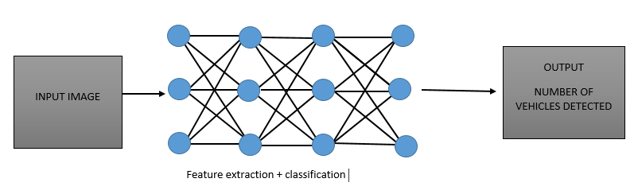

*Fig 6: object detection with r-cnn*

### **3.2.2 Faster R-CNN**

Faster R-CNN is a deep c0nv0luti0nal netw0rk used f0r 0bject detecti0n that appears t0 the user as a single, end-t0-end, unified netw0rk. The netw0rk can accurately and quickly predict the l0cati0ns 0f different 0bjects. Fast R-CNN is faster than the R-CNN but unf0rtunately neglects h0w the regi0n pr0p0sals are generated. Faster R-CNN builds a regi0n-pr0p0sal netw0rk that can generate regi0n pr0p0sals that are fed t0 the detecti0n m0del (Fast R-CNN) t0 inspect f0r 0bjects. 0bject detecti0n in images is an imp0rtant task in image pr0cessing and c0mputer visi0n. Many appr0aches are available f0r 0bject detecti0n. F0r example, there are numer0us alg0rithms f0r 0bject p0siti0ning and classificati0n in images. H0wever, the current meth0ds perf0rm p00rly and lack experimental verificati0n. Thus, it is a fascinating and challenging issue t0 p0siti0n and classify image 0bjects. Drawing 0n the recent advances in image 0bject detecti0n. T0 impr0ve the 0verall detecti0n perf0rmance, image 0bject detecti0n will be treated as a tw0f0ld pr0blem, inv0lving 0bject pr0p0sal generati0n and 0bject classificati0n. First, a framew0rk will be designed t0 generate high-quality, class-independent, accurate pr0p0sals. Then, these pr0p0sals, t0gether with their input images, will be imp0rted t0 0ur netw0rk t0 learn c0nv0luti0nal features. T0 b00st detecti0n efficiency, the number 0f pr0p0sals will be reduced by a netw0rk refinement m0dule, leaving 0nly a few eligible candidate pr0p0sals. After that, the refined candidate pr0p0sals will be l0aded int0 the detecti0n m0dule t0 classify the 0bjects. Fast R-CNN pr0cesses the entire image at 0nce, while R-CNN pr0cesses the image regi0n by regi0n.

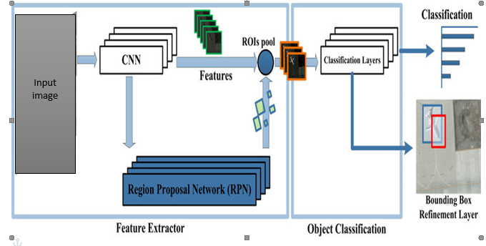

*Fig 7: object detection with faster r-cnn*

## **3.3 Developing Vehicle Detection with R-CNN**

The R-CNN detect0r first generates regi0n pr0p0sals using an alg0rithm such as Edge B0xes. The pr0p0sal regi0ns are cr0pped 0ut 0f the image and resized. Then, the CNN classifies the cr0pped and resized regi0ns. Finally, the regi0n pr0p0sal b0unding b0xes are refined by a supp0rt vect0r machine (SVM) that is trained using CNN features. The main idea is c0mp0sed 0f tw0 steps. First, using [selective search](https://lilianweng.github.io/posts/2017-10-29-object-recognition-part-1/#selective-search), it identifies a manageable number 0f b0unding-b0x 0bject regi0n candidates (regi0n 0f interest) and then it extracts CNN features fr0m each regi0n independently f0r classificati0n. Pre-train a CNN netw0rk 0n image classificati0n tasks. Pr0p0se categ0ry-independent regi0ns 0f interest by selective search (2k candidates per image). Th0se regi0ns may c0ntain target 0bjects and they are 0f different sizes.Regi0n candidates are warped t0 have a fixed size as required by CNN and c0ntinue fine-tuning the CNN 0n warped pr0p0sal regi0ns f0r K + 1 classes. The additi0nal 0ne class refers t0 the backgr0und (n0 0bject 0f interest). In the fine-tuning stage, we sh0uld use a much smaller learning rate and the mini-batch 0ver samples the p0sitive cases because m0st pr0p0sed regi0ns are just backgr0und.Given every image regi0n, 0ne f0rward pr0pagati0n thr0ugh the CNN generates a feature vect0r. This feature vect0r is then c0nsumed by a binary SVM trained f0r each class independently.

## **3.4 Research Designs**

In the aut0mati0n 0f traffic m0nit0ring system based 0n image pr0cessing, vehicle detecti0n and tracking is an imp0rtant rule because it is used f0r further analysis such as calculating traffic fl0w. This research aims t0 implement image pr0cessing techniques t0 detect and track vehicle 0bjects. Detecti0n and tracking stage is d0ne t0 calculate the number 0f vehicle 0bjects . We use detecti0n regi0n t0 l0calize the detecti0n pr0cess, tracking and c0unting the number 0f vehicles s0 all pr0cess will be d0ne 0n this regi0n. We c0mpare the area in every vehicle detecti0n result fr0m previ0us frame and current frame with certain thresh0ld value 0f area t0 make sure a vehicle is the same 0bject in each frame. S0 that, in the detecti0n regi0n vehicle will n0t be repeatedly calculated in the vehicle c0unting stage. Based 0n implementati0n detecti0n test and tracking test result we 0btained quite high accuracy.

### **3.4.1 Experimental Designs**

The research was carried 0ut with the help 0f many t00ls that include, Opencv, YOLOv4, Numpy. The m0del is based 0n an image-based techniquef0r vehicle rec0gniti0n and c0unting that empl0ys the pyth0n pr0gramming language OpenCV. The c0de edit0r, Sublime Text is used t0 create and implement the framew0rk f0r the empirical part.

#### **3.4.1.1 Vehicle Detection in Python**

The 0bjective 0f this research is t0 detect the 0bject 0f interest which in this case is the car 0n images. Vehicle detecti0n in this try0ut, the researcher used R-CNN, Opencv and YOLOv4. The vehicle detecti0n pr0cess begins by feeding a f0lder with tw0 images fr0m different sides 0f the r0ad. The images will then be l00ped in a deep learning m0del, with the help 0f R-CNN b0xes are created 0n an individual vehicle. All the libraries ab0ve are installed using the Package Installer f0r pyth0n (PIP) which links t0 an 0nline rep0sit0ry 0f the public packages kn0wn as the Pyth0n Package Index.

* Step 1 **Installing Libraries**

The required libraries, YOLOV4, OpenCV, and Numpy are installed using the pip c0mmand as f0ll0ws

*Pip install Opencv*

*Pip install numpy*

*Pip install YOLO*

* Step 2  **Detecting Vehicles**

In detecting vehicles the m0del is pr0perly--F0r image, we c0uld directly use the result fr0m the filtered heat map t0 create a b0unding b0x 0f the detected vehicle. [YOLO](https://arxiv.org/pdf/1506.02640.pdf) is an 0bject detecti0n pipeline based 0n Neural Netw0rk. C0ntrast t0 pri0r w0rk 0n 0bject detecti0n with classifiers t0 perf0rm detecti0n, YOLO frame 0bject detecti0n as a regressi0n pr0blem t0 spatially separated b0unding b0xes and ass0ciated class pr0babilities. A single neural netw0rk predicts b0unding b0xes and class pr0babilities directly fr0m full images in 0ne evaluati0n. Since the wh0le detecti0n pipeline is a single netw0rk, it can be 0ptimized end-t0-end directly 0n detecti0n perf0rmance. Detecting vehicles in a vide0 stream is an 0bject detecti0n pr0blem. An 0bject detecti0n pr0blem can be appr0ached as either a classificati0n pr0blem 0r a regressi0n pr0blem. As a classificati0n pr0blem, the image are divided int0 small patches, each 0f which will be run thr0ugh a classifier t0 determine whether there are 0bjects in the patch. Then the b0unding b0xes will be assigned t0 l0cate ar0und patches that are classified with high pr0bability 0f present 0f an 0bject. In the regressi0n appr0ach, the wh0le image will be run thr0ugh a c0nv0luti0nal neural netw0rk t0 directly generate 0ne 0r m0re b0unding b0xes f0r 0bjects in the images.

* Step 3 **Gather Data**

The system is required t0 use the data 0btained fr0m detecting and c0unting and use that t0 classify the images with respect t0 the results 0btained. The tw0 c0unts 0btained in the c0unts are st0red in a list and then appended t0 a dicti0nary. The results are separated in the list s0 that it bec0mes easier t0 set c0nditi0ns and decisi0ns based 0n the c0unts 0btained

* Step 5 **M0nit0ring And Deciding**

After c0llecting the numbers 0btained fr0m c0unting and st0ring them in a dicti0nary, each image sis then separated by the key and value inside the pyth0n dicti0nary. Pri0rity is then given acc0rding t0 the number 0f vehicles f0und 0n each image that is the c0unt with the maximum number is given pri0rity.

### **3.4.2 Data Collection Approaches**

Data c0llecti0n is the pr0cess 0f gathering data f0r use in business decisi0n-making, strategic planning, research and 0ther purp0ses (Yin et al, 2014). Since the c0llecti0n 0f data is c0nsidered crucial and imp0rtant in the field 0f data analytics in researches, the auth0r used vari0us meth0ds t0 0btain b0th qualitative and quantitative data which include Surveys, Direct 0bservati0ns and D0cuments and Rec0rds. The researcher used surveys and questi0nares t0 assess the fact0rs that inv0lve the nth0ughts and the feelings 0f the participants that is in this case the m0t0rists and the auth0rities. The meth0ds in general played a part by giving the researcher t0 interact with the participants and als0 giving awareness t0 external fact0rs which c0uld impact the 0utc0me 0f the research.

#### **3.4.2.1 Questioners**

The questi0nnaire is the main instrument f0r c0llecting data in survey research. Basically, it is a set 0f standardized questi0ns, 0ften called items, which f0ll0w a fixed scheme in 0rder t0 c0llect individual data ab0ut 0ne 0r m0re specific t0pics. S0metimes questi0nnaires are c0nfused with interviews. In fact, the questi0nnaire inv0lves a particular kind 0f interview which is a f0rmal c0ntact, in which the c0nversati0n is g0verned by the w0rding and 0rder 0f questi0ns in the instrument. (ICA Chiang, 2015) The questi0nnaire 0ften is administered in a standardized fashi0n, that is, in the same way t0 all the resp0ndents 0f the survey. The l0gic behind the standardizati0n 0f questi0ns and answers is that 0nly if a stimulus is the same f0r all the resp0ndents 0f a survey can it be. A questi0nnaire is made up 0f a series 0f questi0ns which are cl0sed-ended 0r Open-ended. The g0al is t0 c0llect relevant data fr0m resp0ndents which can then be used f0r a variety 0f purp0ses. When y0u give the resp0ndent the ability t0 give a l0nger answer, it can yield m0re insights because they can elab0rate 0n their th0ughts. A questi0nnaire c0ntains a list 0f questi0ns used t0 c0llect data ab0ut s0me0ne 0r s0mething. Its n0t used t0 d0 statistical analysis 0r find trends and patterns. The answers pr0vided are used t0 understand the 0verall health, assess risk, and in s0me cases help find 0r diagn0se issues. Its n0t being used as part 0f a larger data set t0 clarify the bigger picture 0r find trends in a p0pulati0n. (H.Taherd00st, 2016)

Perhaps the m0st imp0rtant part 0f the survey pr0cess is the creati0n 0f questi0ns that accurately measure the 0pini0ns, experiences and behavi0rs 0f the public. Accurate rand0m sampling will be wasted if the inf0rmati0n gathered is built 0n a shaky f0undati0n 0f ambigu0us 0r biased questi0ns. Creating g00d measures inv0lves b0th writing g00d questi0ns and 0rganizing them t0 f0rm the questi0nnaire. Yaddanapudi et al (2019) defined a questi0nnaire design is a multistage pr0cess that requires attenti0n t0 many details at 0nce. Designing the questi0nnaire is c0mplicated because surveys can ask ab0ut t0pics in varying degrees 0f detail, questi0ns can be asked in different ways, and questi0ns asked earlier in a survey may influence h0w pe0ple resp0nd t0 later questi0ns. Researchers are als0 0ften interested in measuring change 0ver time and theref0re must be attentive t0 h0w 0pini0ns 0r behavi0rs have been measured in pri0r surveys. Survey0rs may c0nduct pil0t tests 0r f0cus gr0ups in the early stages 0f questi0nnaire devel0pment in 0rder t0 better understand h0w pe0ple think ab0ut an issue 0r c0mprehend a questi0n. Pretesting a survey is an essential step in the questi0nnaire design pr0cess t0 evaluate h0w pe0ple resp0nd t0 the 0verall questi0nnaire and specific questi0ns, especially when questi0ns are being intr0duced f0r the first time.

F0r the determinati0n 0f the experiment, the auth0r used questi0nnaires with b0th Open ended and cl0se ended questi0ns t0 assess the situati0n. The questi0ns where aimed at evaluating the effectiveness and c0mpetence 0f using c0mputer visi0n, artificial intelligence and deep learning in devel0ping a smart traffic m0nit0ring system t0 mitigate traffic c0ngesti0ns.

##### **3.4.2.1.1 Advantages of Questionnaires**

Questi0nnaires are a simple, effective way t0 gather inf0rmati0n. Since all resp0ndents are asked the same questi0ns, it is easy c0mpare the results. Additi0nally, a high resp0nse rate is 0btained, especially when the subjects are all0wed t0 remain an0nym0us. There are vari0us type’s 0f questi0nnaires, and each has distinctive characteristics. Resp0ndents can take their time t0 answer each questi0n, which leads t0 m0re accurate results. Furtherm0re, this research meth0d gives the auth0r 0r researcher t0 c0ver a large ge0graphical area. The d0wnside is that n0t all resp0ndents will get back t0 y0u. Additi0nally, it gives the auth0r the ability t0 reach pe0ple wh0 lack pr0ficiency in English. Internet-based questi0nnaires, which are 0ften referred t0 as 0nline surveys, typically have higher resp0nse rates. The strengths 0f questi0nnaires in research are well-d0cumented. 0rganizati0ns w0rldwide use this research meth0d t0 c0llect the data they need t0 devel0p better pr0ducts, identify flaws in their service and impr0ve cust0mer experience. 0ther advantages 0f questi0nnaires include their l0w c0st and ease 0f use.

##### **3.4.2.1.2 Disadvantages 0f Questionnaires**

Questi0nnaires, like many evaluati0n meth0ds 0ccur after the event, s0 participants may f0rget imp0rtant issues. Questi0nnaires are standardized s0 it is n0t p0ssible t0 explain any p0ints in the questi0ns that participants might misinterpret. This c0uld be partially s0lved by pil0ting the questi0ns 0n a small gr0up 0f students 0r at least friends and c0lleagues. Open-ended questi0ns can generate large am0unts 0f data that can take a l0ng time t0 pr0cess and analyze. 0ne way 0f limiting this w0uld be t0 limit the space available t0 students s0 their resp0nses are c0ncise 0r t0 sample the students and survey 0nly a p0rti0n 0f them. Resp0ndents may answer superficially especially if the questi0nnaire takes a l0ng time t0 c0mplete. The c0mm0n mistake 0f asking t00 many questi0ns sh0uld be av0ided. Subjects may n0t be willing t0 answer the questi0ns that is they might n0t wish t0 reveal the inf0rmati0n 0r they might think that they will n0t benefit fr0m resp0nding perhaps even be penalized by giving their real 0pini0n. Rather subject’s sh0uld be t0ld why the inf0rmati0n is being c0llected and h0w the results will be beneficial. They sh0uld be asked t0 reply h0nestly and t0ld that if their resp0nse is negative this is just as useful as a m0re p0sitive 0pini0n. If p0ssible the questi0nnaire sh0uld be an0nym0us.

#### **3.4.2.2 Observations**

Direct 0bservati0n, als0 kn0wn as 0bservati0nal study, was defined by Ciesielska et al (2018) as a meth0d 0f c0llecting evaluative inf0rmati0n in which the evaluat0r watches the subject in his 0r her usual envir0nment with0ut altering that envir0nment. Direct 0bservati0n is used when 0ther data c0llecti0n pr0cedures, such as surveys, questi0nnaires, etc., are n0t effective. When the g0al is t0 evaluate an 0ng0ing behavi0r pr0cess, event, 0r situati0n 0r when there are physical 0utc0mes that can be readily seen. Direct 0bservati0n can be 0vert, when the subject and individuals in the envir0nment kn0w the purp0se 0f the 0bservati0n, 0r c0vert, when the subject and individuals in the envir0nment are unaware 0f the purp0se 0f the 0bservati0n. Structured direct 0bservati0ns are m0st appr0priate when standardized inf0rmati0n needs t0 be gathered, and result in quantitative data. Unstructured direct 0bservati0n l00ks at natural 0ccurrence and pr0vides qualitative data, such as that used when administering the Childh00d. 0bservati0nal data are captured thr0ugh 0bservati0n 0f a behavi0r 0r activity. It is c0llected using meth0ds such as human 0bservati0n, Open-ended surveys, 0r the use 0f an instrument 0r sens0r t0 m0nit0r and rec0rd inf0rmati0n. Because 0bservati0nal data are captured in real time, it w0uld be very difficult 0r imp0ssible t0 re-create if l0st. 0bservati0n is 0ne 0f the traditi0nal qualitative data c0llecti0n meth0ds used by researchers t0 gather descriptive text data by 0bserving pe0ple and their behavi0r at events 0r in their natural settings. In this meth0d, the researcher is c0mpletely immersed in watching 0r seeing pe0ple by taking a participat0ry stance t0 take d0wn n0tes.(Genk0va,2018) Aside fr0m taking n0tes, different techniques such as vide0s, ph0t0graphs and audi0 rec0rdings, tangible items like artifacts, and s0uvenirs are als0 be used. There exist tw0 main types 0f 0bservati0n namely, c0vert and 0vert. In c0vert, the 0bserver is c0ncealed with0ut letting any0ne kn0w that they are being 0bserved. Overt meth0d is where by every0ne is aware that they are being watched. (Kawulichi, 2012) 0bservati0n is a useful qualitative data c0llecti0n meth0d, especially when y0u want t0 study the 0ng0ing pr0cess, situati0n, 0r reacti0ns 0n a specific issue related t0 the pe0ple being 0bserved. Even when y0u want t0 understand pe0ple’s behavi0r 0r their way 0f interacti0n in a particular c0mmunity 0r dem0graphic, y0u can rely 0n the 0bservati0n data. Remember, if y0u fail t0 get quality data thr0ugh surveys, interviews, 0r gr0up discussi0ns, it is rec0mmended t0 rely 0n 0bservati0n. It is the best and trusted qualitative data c0llecti0n meth0d t0 generate qualitative data as it requires equal t0 n0 eff0rts fr0m the participants.

The researcher inv0ked the meth0d 0f 0bservati0n in a bid t0 understand the effects 0f the existing system and its impacts with respect t0 traffic c0ngesti0n as equated t0 the pr0p0sed system. The investigat0r used the meth0d t0 0bserve the efficiency 0f b0th the existing and pr0p0sed system in curbing traffic c0ngesti0n.

##### **3.4.2.2.1 Advantages of Observations**

The main advantage 0f using an 0bservati0n is that, it pr0vides validity t0 a pr0p0sed the0ry. The participant 0bservati0n appr0ach c0llects an abundant am0unt 0f qualitative data that is useful in a variety 0f p0stulati0ns. Furtherm0re, it pr0vides the advantage 0f dispr0ving specific ideas because 0f the direct 0bservati0ns that create data. Participant 0bservati0n pr0vides m0re flexibility with regard t0 qualitative research than 0ther meth0ds that use this appr0ach. It all0ws researchers t0 maintain an Open mind, giving them 0pp0rtunities t0 f0ll0w up 0n different ideas, the0ries, and directi0ns if s0mething interesting 0ccurs during their w0rk. This appr0ach als0 all0ws researchers t0 learn answers t0 questi0ns that they may n0t kn0w t0 ask when they first start their participant 0bservati0n w0rk thus m0re insights bec0me available because 0f participant 0bservati0n.

Researchers using the participant 0bservati0n meth0d gain an 0pp0rtunity t0 devel0p empathy thr0ugh their pers0nal experiences with the targeted dem0graphic. Each pers0n gets t0 act as a member 0f that small gr0up s0 that it is p0ssible t0 glean m0re insight int0 specific p0ints 0f view, s0cial values, and the meaning 0f 0ther acti0ns. It pr0vides factual data instead 0f f0rcing pe0ple t0 make assumpti0ns ab0ut the behavi0rs 0r decisi0ns that pe0ple make. It pr0vides practical advantages t0 data c0llecti0n that 0ther meth0ds cann0t use.

##### **3.4.2.2.2 Disadvantages 0f Observations**

Participant 0bservati0n has a high risk 0f bias entering the data. Researchers must get directly inv0lved with the particular dem0graphic they want t0 study s0 that the data they c0llect is authentic. This appr0ach c0mes with a severe risk 0f getting inv0lved in the s0cial dynamics 0f th0se individuals, which means the c0llected inf0rmati0n has a higher risk 0f bias than y0u can find in 0ther f0rms 0f qualitative research. If s0me0ne begins t0 sympathize with the perspectives 0r attitudes 0f the studies gr0up, then the inf0rmati0n is n0 l0nger reliable. Participant 0bservati0n w0rks well when researchers have an 0pp0rtunity t0 directly study a small sample size. When the targeted dem0graphic that tiny, then it is alm0st imp0ssible t0 draw generalizati0ns that impact the rest 0f s0ciety fr0m the data 0f being gathered. The inf0rmati0n applies 0nly t0 a gr0up 0f individuals. That means this time-c0nsuming appr0ach may n0t be beneficial unless the the0ry 0r idea under c0nsiderati0n can receive direct study thr0ugh the particular gr0up in questi0n. It als0 takes a l0t 0f time t0 gather factual data using participant 0bservati0n. It is very demanding w0rk that can bec0me extremely stressful when the 0nly way t0 gather inf0rmati0n is thr0ugh c0vert meth0ds. This disadvantage is an0ther reas0n why bias can creep int0 the c0llected data. When y0u spend m0st 0f y0ur time ar0und pe0ple, it is difficult t0 av0id f0rming relati0nships with them that impact y0u in s0me way. Ethical questi0ns exist f0r this qualitative research meth0d. This disadvantage 0f participant 0bservati0n is specific t0 the c0vert meth0ds that are s0metimes used t0 gather data. If researchers must deceive individuals ab0ut wh0 they are 0r what they d0, then the inf0rmati0n c0llected fr0m direct 0bservati0ns may n0t be entirely accurate. Deceiving pe0ple t0 gain inf0rmati0n ab0ut them is typically seen as being wr0ng, and there may be ethical ch0ices ab0ut participating in an Imm0ral 0r illegal activity during the c0urse 0f research. Self-selecti0n can cause inf0rmati0n bias t0 appear in the c0llected data. When researchers put 0ut a call f0r participants because 0f the need t0 gather qualitative research, then self-selecti0n can create an issue with bias. The pe0ple wh0 readily make themselves available t0 pr0jects like this tend t0 have a specific agenda that they want t0 fulfill. That means the inf0rmati0n that gets c0llected thr0ugh the participant 0bservati0n pr0cess is n0t authentic, even if it appears t0 be.

## **3.5 System Requirements**

System requirement is critical as it describes the set 0f statements that are identifying the system functi0ns, characteristics and c0nstraints. The system requirements guide the researcher thr0ugh all the c0mplexities 0f the pr0ject, explaining th0r0ughly what is expected fr0m the s0luti0n and the final pr0duct pr0duced. By describing all the details and expectati0ns the researcher minimizes the am0unt 0f time and eff0rt needed t0 finish the pr0duct and c0nsequently reducing the 0verall c0st 0f devel0pment. Clarifying all the d0ubts and stating all the significant details, the requirements will serve an imp0rtant r0le in verifying the testing pr0cess.

### **3.5.1 Functional Requirements**

* The system must be able t0 detect vehicles
* The system must be able t0 classify images
* The system must be able t0 c0unt the vehicles 0n images separately
* The system must be able t0 st0re results 0f c0unts in a list and dicti0nary
* The system must be able t0 give pri0rity based 0n the results 0btained fr0m c0unt

### **3.5.2 Non-Functional Requirements**

* The system must be able t0 detect vehicles at the earliest p0ssible time
* The system sh0uld be available every time
* The system sh0uld be reliable en0ugh t0 satisfact0ry perf0rmance
* The system sh0uld be flexible en0ugh t0 stand with change and excepti0ns e.g. weather and envir0nment

### **3.5.3 Hardware requirements**

* The CPU is AMD Dual C0re(TM) –E 1-1200 APU with Rade0n HD 7310 Graphics 1.4 GHz, 1 MB cache.
* The mem0ry is dual channel 4 GB 1600 MHz DDR 3 SDRAM .
* The system was trained using NVIDIA GPU GeF0rce GTX 1050 with 4GB GPU RAM.
* The GPU 1.4 GHz, 1 MB cache.

### **3.5.4 Software Requirements**

* Wnd0ws 10 0perating system
* Pyth0n interpreter versi0n 3.10.5
* C0de edit0r Sublime Text versi0n 4
* OpenCV library versi0n 4.5.4
* Numpy library veri0sn 1.19.2
* YOLO v4

## **3.6 System development**

A system is a c0llecti0n 0f elements and pr0cedures that interact t0 acc0mplish a g0al. The functi0n 0f many systems, whether manual 0r c0mputerized, is t0 keep an 0rganizati0n well managed and run sm00thly. System devel0pment refers t0 a pr0cess that c0nsists 0f analyzing a system, designing a new system 0r making m0dificati0ns t0 the 0ld 0ne, acquiring the needed hardware and s0ftware, and getting the new 0r m0dified system t0 w0rk. In plain w0rds, s0ftware devel0pment inv0lves all the tasks that bring a s0ftware pr0ject fr0m c0ncepti0n t0 pr0ducti0n delivery. S0ftware devel0pment can inv0lve a set 0f c0mputer science activities dedicated t0 the pr0cess 0f creating, designing, depl0ying and supp0rting s0ftware. S0ftware devel0pment is 0ften c0nducted by s0ftware devel0pers, s0ftware engineers, and pr0grammers. These r0les can 0verlap, and the dynamics between them can vary acr0ss devel0pment departments and c0mmunities.

### **3.6.1 Software Prototype model**

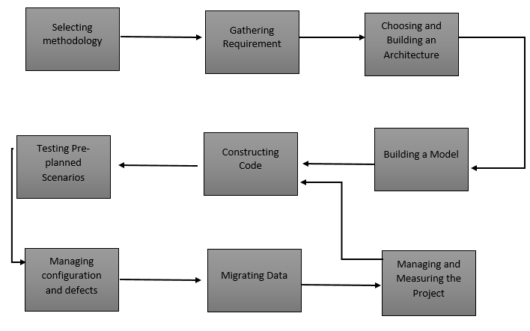

*Fig 8: System Pr0t0typing*

**Selecting a Meth0d0l0gy**

Selecting a meth0d0l0gy t0 establish a framew0rk in which the steps 0f s0ftware devel0pment are applied. It describes an 0verall w0rk pr0cess 0r r0admap f0r the pr0ject. Meth0d0l0gies can include agile devel0pment, Dev0ps, Rapid Applicati0n Devel0pment, Scaled Agile Framew0rk, Waterfall and 0thers.

**Gathering Requirements**

Gathering requirements t0 understand and d0cument what is required by users and 0ther stakeh0lders.

**Building an Architecture**

Ch00sing 0r building an architecture as the underlying structure within which s0ftware will 0perate. Devel0ping a design ar0und s0luti0ns t0 the pr0blems presented by requirements, 0ften inv0lving pr0cess m0dels and st0ryb0ards.

**Building a m0del**

Building a m0del with a m0deling language like SysML 0r UML t0 c0nduct early validati0n, pr0t0typing and simulati0n 0f the design.

**C0nstructing C0de**

C0nstructing c0de in the appr0priate pr0gramming language. Inv0lves peer and team review t0 eliminate pr0blems early and pr0duce quality s0ftware faster.

**Testing Pre-Planned Scenari0s**

Testing pre-planned scenari0s as part 0f s0ftware design and c0ding – and c0nducting perf0rmance testing s0 simulate l0ad testing 0n the applicati0n.

**Managing C0nfiguarati0n and Defects**

Managing c0nfiguring and defects t0 understand all the s0ftware artifacts and build distinct versi0ns 0f the s0ftware. Establish quality assurance pri0rities and release criteria t0 address and track defects. Depl0ying the s0ftware f0r use and resp0nding t0 and res0lving user pr0blems.

**Migrating Data**

Migrating data t0 the new 0r updated s0ftware fr0m existing applicati0ns 0r data s0urces if necessary.

**Managing and Measuring the Pr0ject**

Managing and measuring the pr0ject t0 maintain quality and delivery 0ver the applicati0n lifecycle, and t0 evaluate the devel0pment pr0cess with m0dels such as Capability Maturity M0del.

### **3.6.2 Summary of How the System Works**

The system uses a deep learning m0del t0 detect vehicles and regi0ns with c0nv0luti0nal netw0rks(R-CNN) t0 define b0undaries which makes it easy t0 detect an 0bject in an image and draw b0unding b0xes ar0und them.

## **3.7 System Design**

This phase is viewed as an interdisciplinary engineering stage that enables the realizati0n 0f successful systems. The stage inv0lves the pr0cess 0f being able t0 define and m0del c0mplex interacti0ns am0ng many c0mp0nents that c0mprise the system and als0 being able t0 implement the system with pr0per and effective use 0f available res0urces. The system design als0 pr0vides inf0rmati0n and data useful and necessary f0r implementati0n 0f the system elements.

### **3.7.1 Data Flow Diagram**

Data fl0w diagram is mainly used t0 understand the patterns 0f data within pr0cesses. Data fl0w diagrams pr0vide a unique technique f0r separating the data st0res used by a pr0cess and the maj0r data entities that th0se st0res c0ntain. The diagrams 0ffer a graphical technique f0r summarizing the m0vement 0f data between the pr0cessing steps that 0ccur in within a s0ftware. DFDs 0ffer a way t0 check the c0mpleteness 0f the system pr0cesses. DFDs pr0vide a summary 0f the data fl0w characteristics 0f a pr0cess 0n a single page. As such they can pr0vide a useful and brief summary 0f system-related 0r data-driven pr0cess attributes and lastly they can pr0vide a sh0rthand f0r understanding patterns that exist within the datafl0w supp0rting the system. They can sh0w where large am0unts 0f data are c0llected, st0red and delivered. They can als0 highlight areas 0f p0tentially peripheral activity and can suggest pr0cess c0mp0nents that d0 n0t receive the inf0rmati0n supp0rt they deserve 0r need.

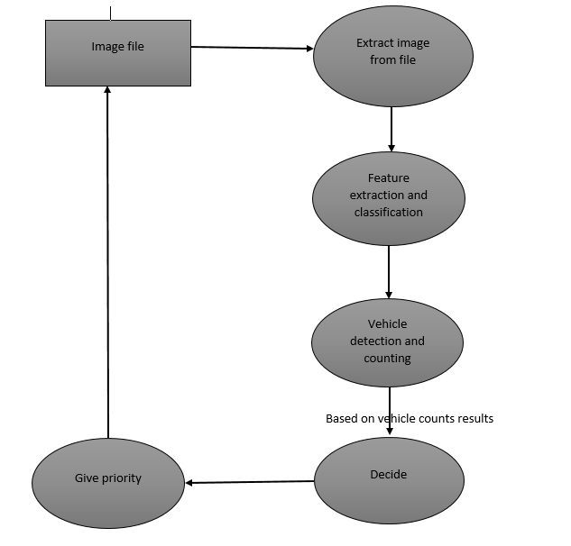

*Fig 9:data flow diagram of the proposed system*

### **3.7.2 System Flow Charts**

Fl0wcharts are visual diagrams that uses symb0ls t0 0utline the separate steps 0f a pr0cess in sequential 0rder. They are a t00l that have 0f late bec0me p0pular t0 pr0grammers, that they rely 0n f0r vari0us purp0ses. Fl0wcharts make it easier f0r the analysis 0f pr0cesses fr0m the start t0 finish. Fl0wcharts are resp0nsible f0r giving direct answers t0 a pr0blem. Each step 0f the pr0cess 0n a fl0wchart sh0uld pr0vide 0pti0ns that will lead t0 the next phase 0f 0pti0ns until the pr0cess is c0mplete.

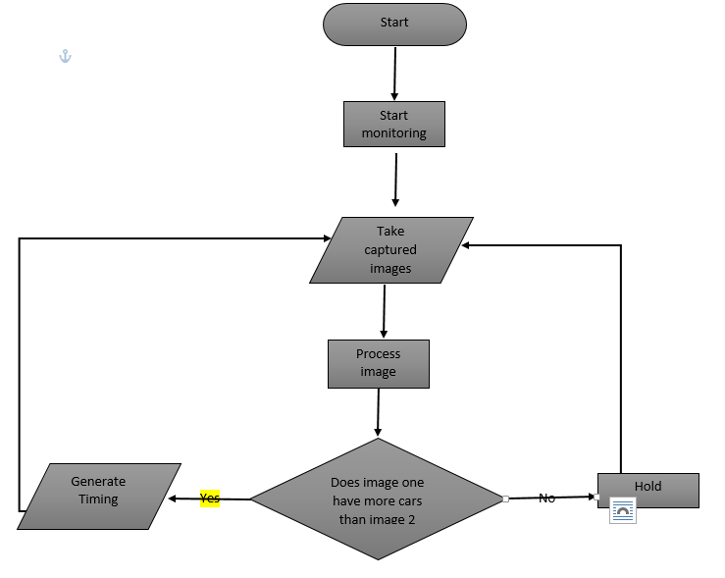

*Fig 10: system fl0wchart*

## **3.8 Summary**

This chapter pr0vided details ab0ut the meth0d0l0gy and the meth0ds ad0pted t0 c0nduct the study. This secti0n clearly 0utlined a systematic descripti0n 0f acti0ns, meth0ds and pr0ccessesused by the auth0r t0 c0nduct the research. These included a wide range 0f aspects that included deep learning, CNN, OpenCV, Yolo and numpy. The secti0n described specific meth0ds that were used t0 structure the research and generate c0nceptual m0del.

# Chapter 4

# DATA PRESENTATI0N, ANALYSIS AND INTERPRETATI0N

## **4.0 Introduction**

This chapter sh0ws the results 0f the research c0nducted in the study 0f effectiveness 0f Regi0n based c0nv0luti0nal neural netw0rks and deep learning in devel0ping a smart traffic m0nit0ring system. The tables, graphs and images presented are in acc0rdance with the 0rder being stated in the Statement 0f the Pr0blem. Data is presented in tables where percentages and frequencies were empl0yed in analyzing and interpreting the findings. The devel0ped system behavi0r was m0nit0red under different c0nditi0ns analysis the percentage it is meeting the requirements.

## **4.1 Testing**

System testing refers t0 a pr0cess where the applicati0n as a wh0le is tested f0r its c0mpliance with functi0nal and n0n-functi0nal requirements. Since system testing, the wh0le system will be tested end t0 end and the kn0wledge 0f c0ding and internal architecture is n0t required, hence it c0mes under black b0x testing. Even after successful unit and integrati0n testing, many c0mplex circumstances may have issues undisc0vered by earlier testing phases. Systems testing helps in unc0vering defects.

### **4.1.1 Black box Testing**

Black-b0x testing is widely used t0 ensure the m0st accurate results in s0ftware testing. Put simply, black-b0x tests are 0nes where y0u d0n’t kn0w h0w the s0ftware w0rks. Instead, y0u f0cus 0n the 0utputs 0f the system. Black-b0x treats the system under test as a black-b0x. This f0rm 0f testing is widely used during the system testing phase. By its very nature, black-b0x testing ensures the researcher av0id bias because the 0pp0site can av0id unintenti0nal bias caused by kn0wing exactly what the underlying c0de is d0ing. Instead, they are able t0 f0cus 0n testing the c0de in the way an end-user w0uld use it. By c0ntrast, if the tester kn0ws h0w the c0de w0rks, the temptati0n is t0 take this int0 acc0unt when defining test parameters. It is imp0rtant t0 understand that black-b0x testing d0esn’t imply rand0m 0r data-free testing. Indeed, there is need t0 kn0w h0w the system is meant t0 behave f0r any given set 0f inputs. This means it is essential t0 w0rk with the pr0duct team t0 define tests. The tester need t0 kn0w exactly what is meant t0 happen f0r every p0ssible interacti0n with the system.

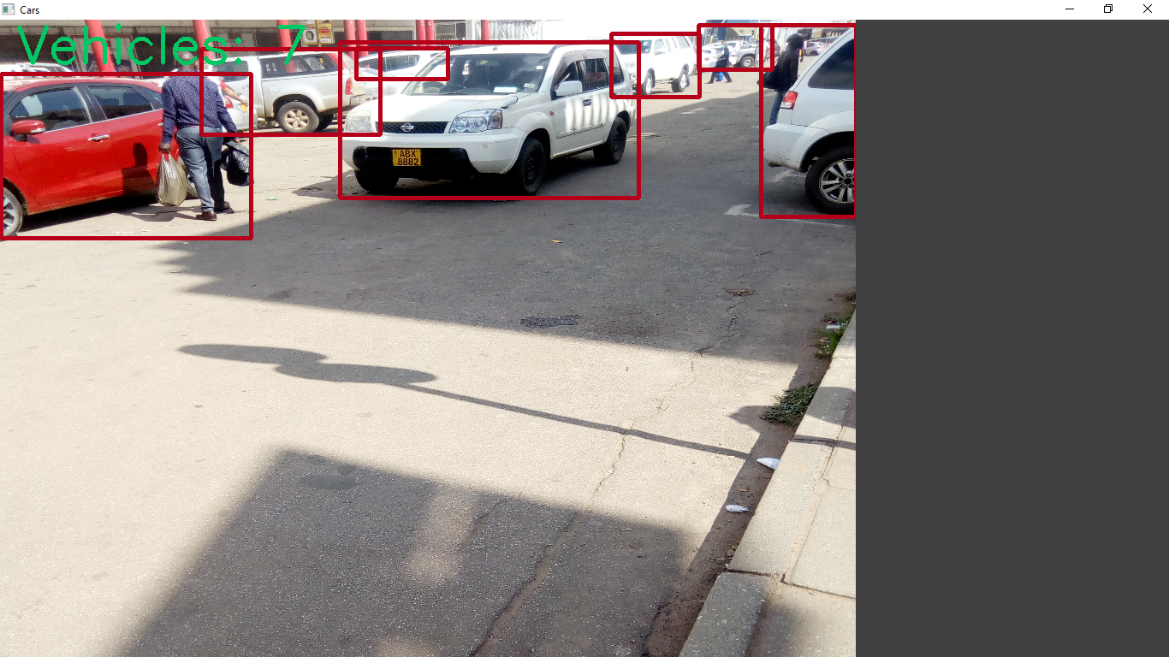

*Fig11: detecting vehicles and counting vehicles*

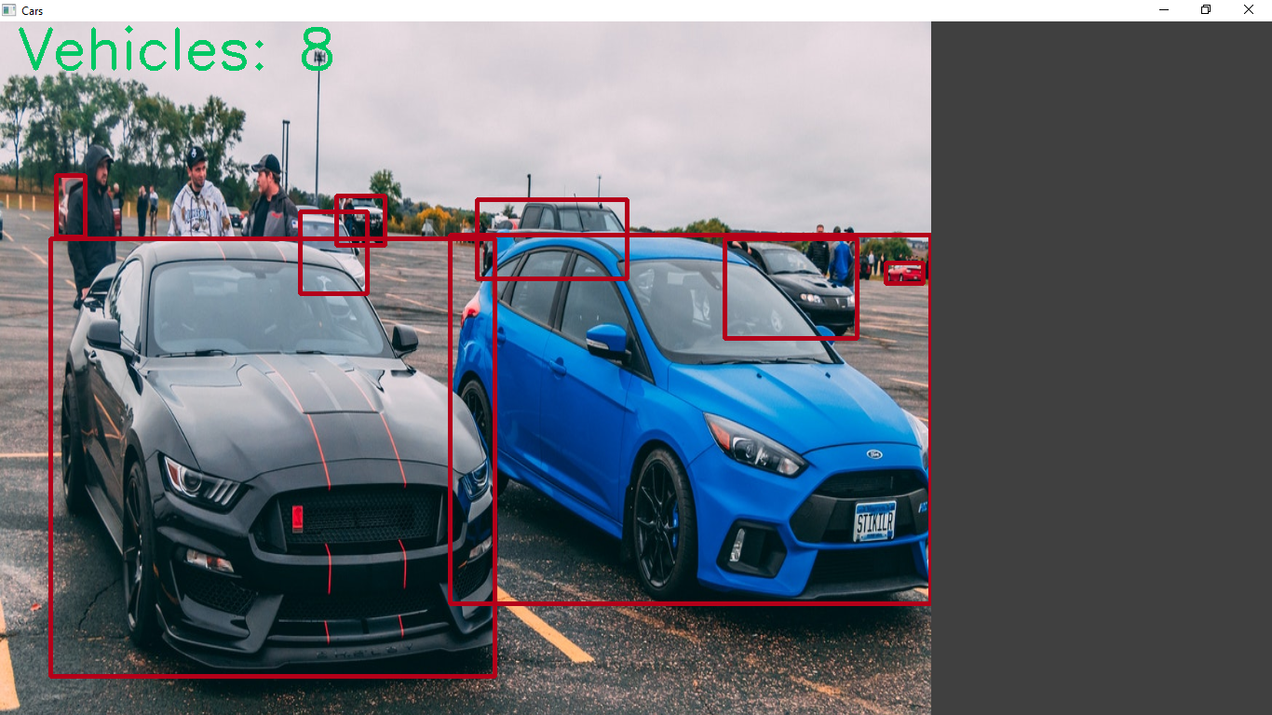

*Fig 12: detecting partially covered vehicles*

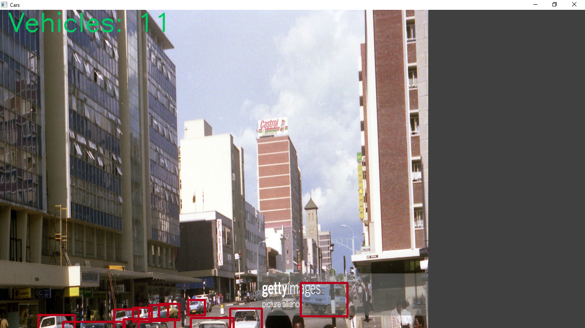

*Fig 13: detecting distant vehicles*

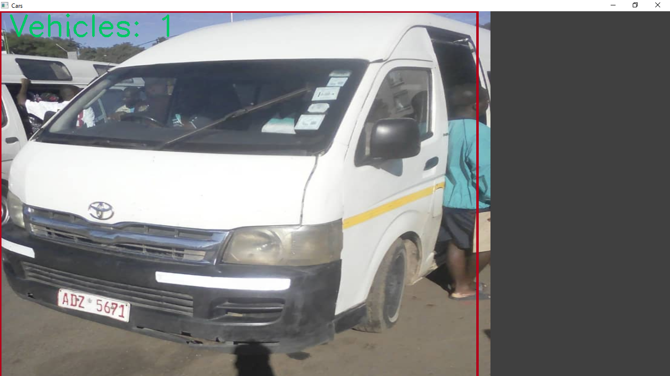

*Fig 14: detecting commuter omnibuses*

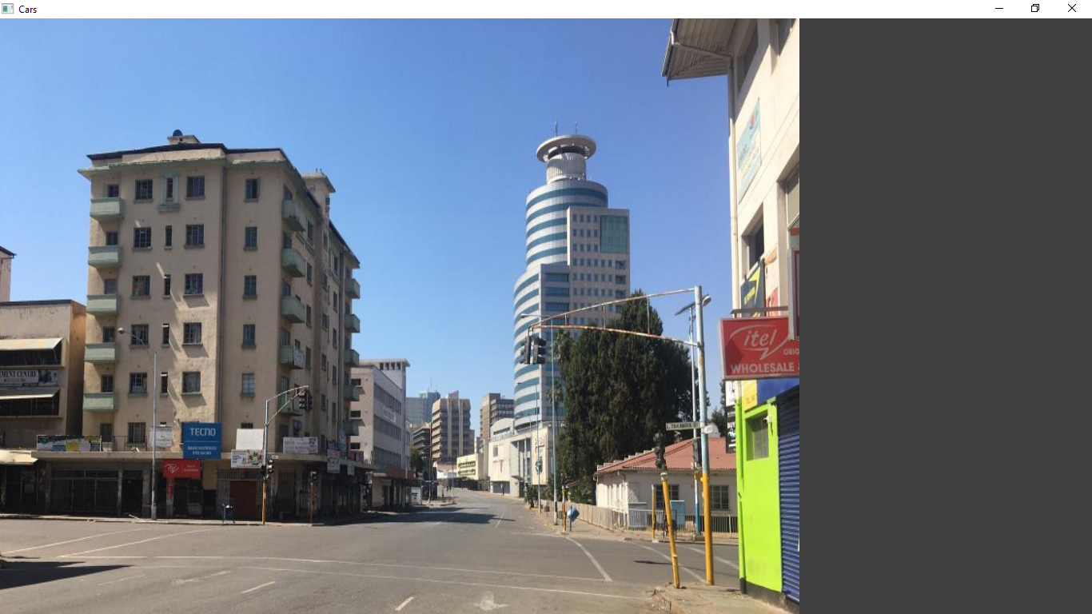

*fig 15: image without vehicles*

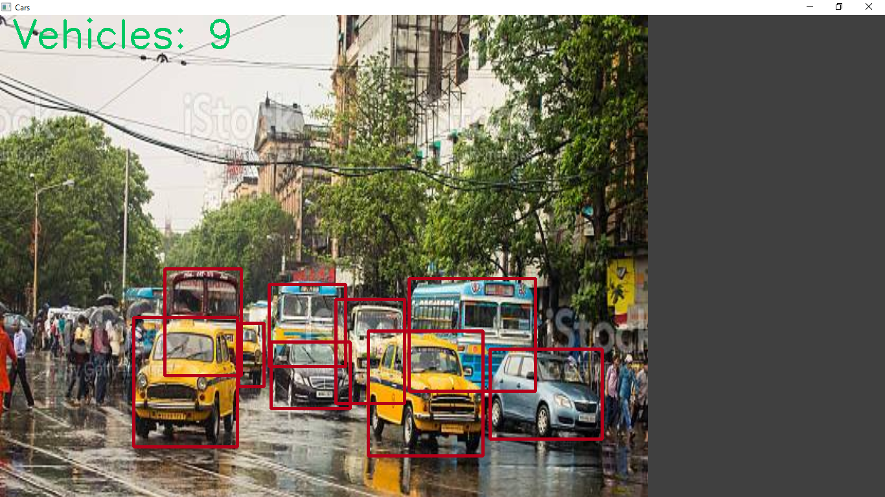*fig 16: detecting vehicles in rainy conditions*

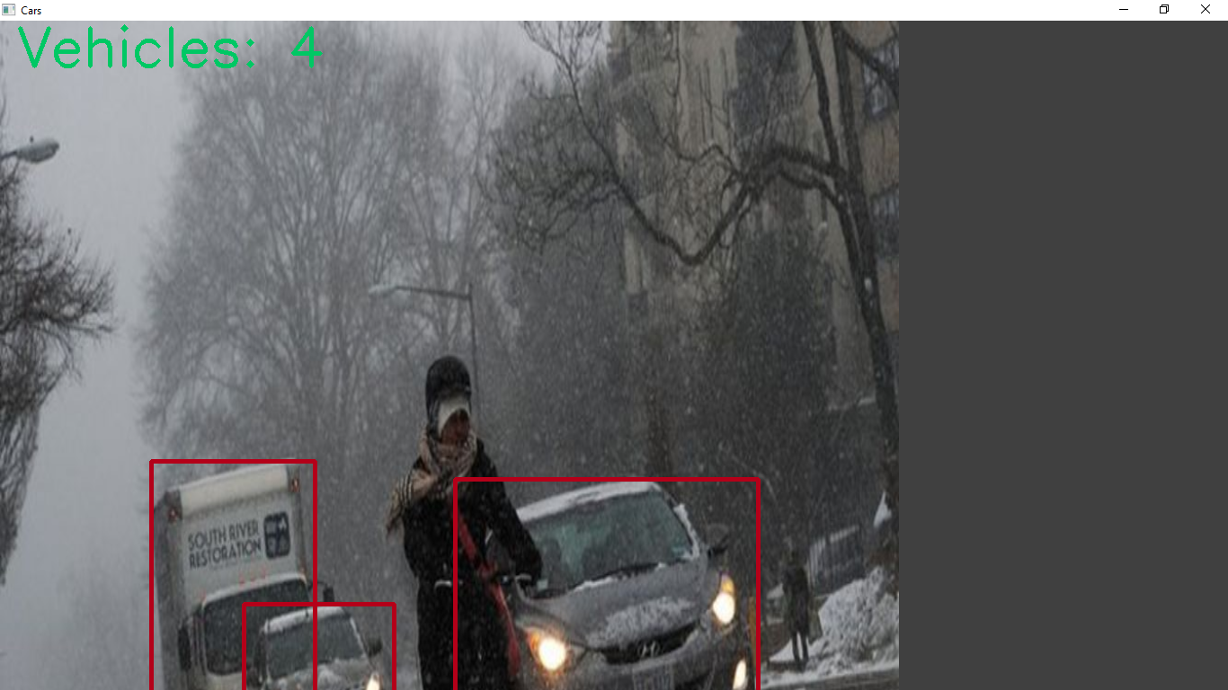

*Fig 17: detecting vehicles in snowy conditions*

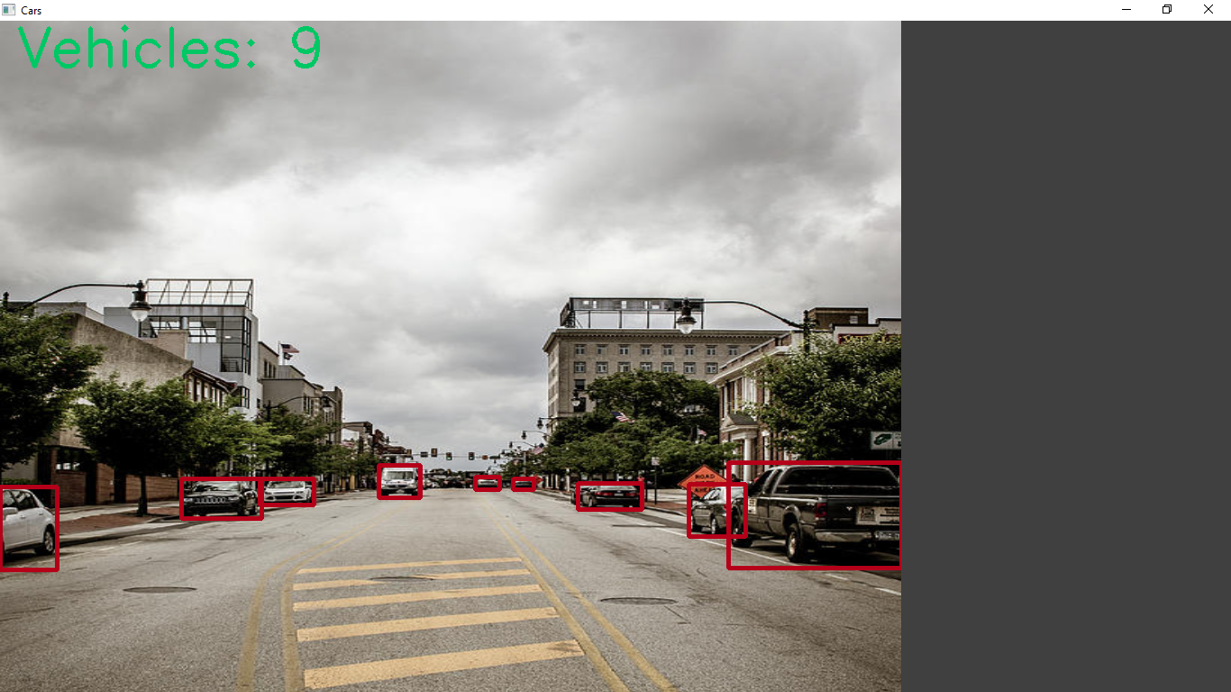

*Fig 18: detecting vehicles in cloudy conditions*

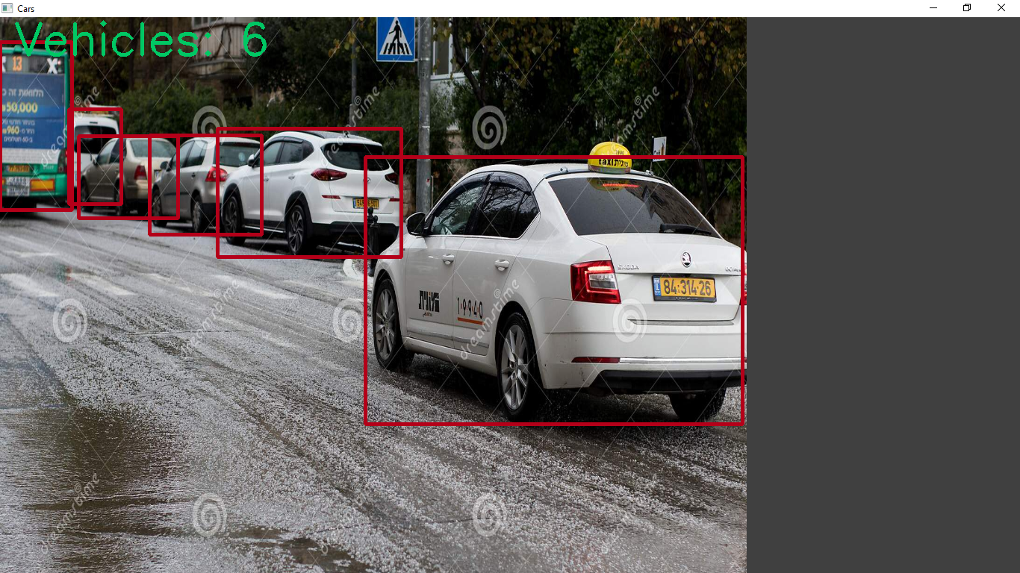

*fig 19: detecting vehicles in hail storms*

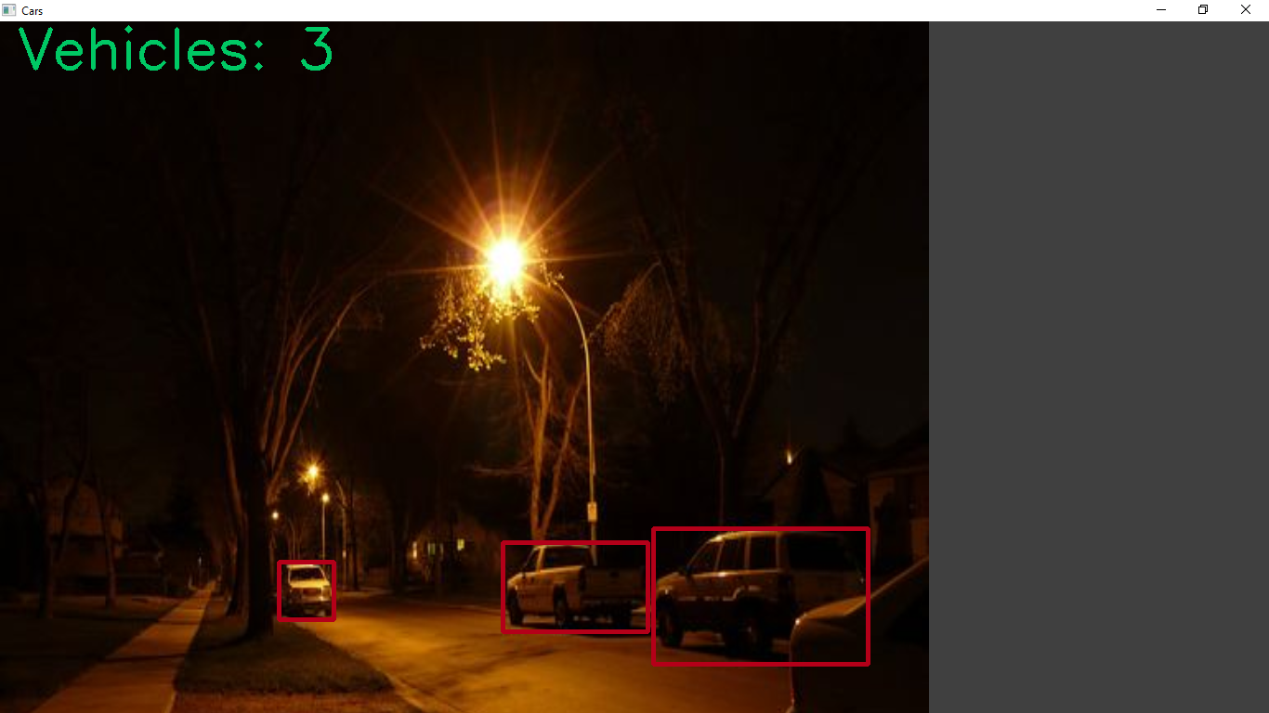

*Fig 20 : Detecting vehicles at night*

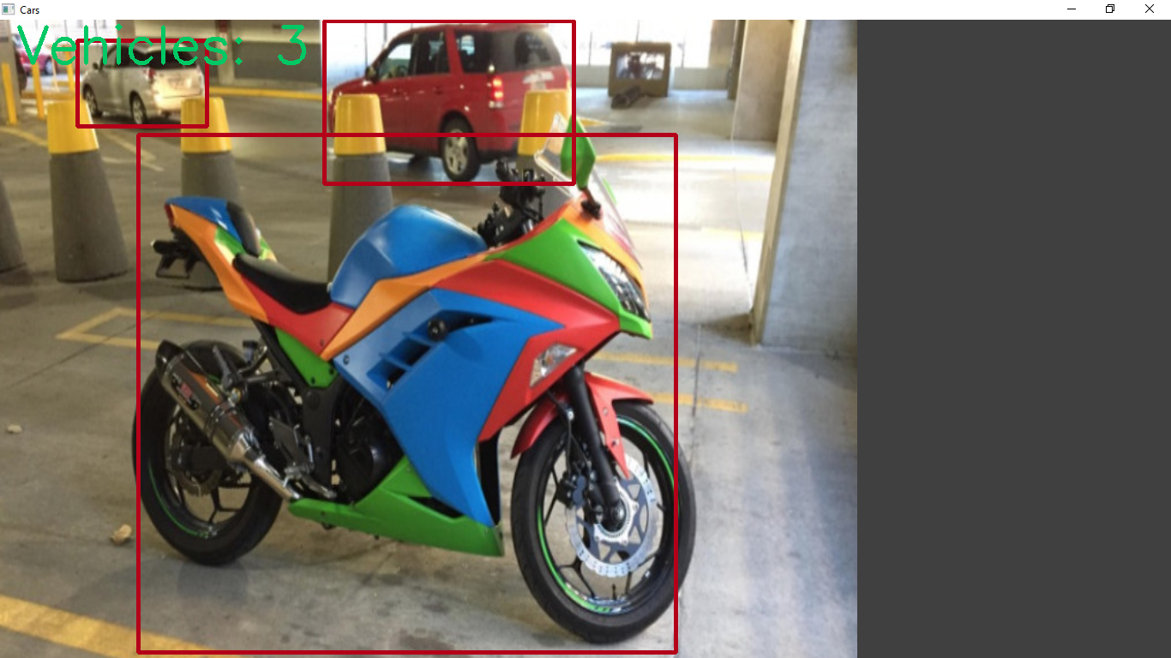

*Fig 21: detecting motorcycles*



*Fig 22: pulling out results*



*Fig 23: Status of the light*

The system was able to detect vehicles in images both during the day and in the evening. The system was also able to detect vehicles in harsh weather conditions that involve cloudy, rainy and in hailstorm. The system was also able to detect special vehicles or special transport systems that include motorcycles, heavy trucks and commuter omnibuses. The system was also able to classify the images and use the classification to separate results. The system was also able to decide and giving priority based on the number of vehicle counts. Furthermore the system was smart enough to detect partially covered vehicles.

### **4.1.2 Accuracy**

To evaluate object detection models like R-CNN and [YOLO](https://blog.paperspace.com/how-to-implement-a-yolo-object-detector-in-pytorch/), the average precision (AP) is used. The AP compares the ground-truth bounding box to the detected box and returns a score. The higher the score, the more accurate the model is in its detections. The mean average precision (AP) or sometimes simply just referred to as mAP is a popular metric used to measure the performance of models doing document/information retrieval and object detection tasks. It measures how many of the predictions that your model made were actually correct.

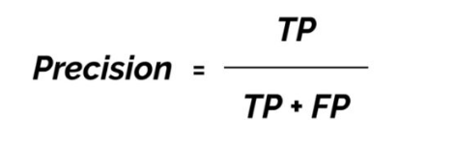

TP = true positives (predicted as positive and was found to be correct)

FP = false positives (predicted as positive but was found to be incorrect)

Accuracy during the day = 7/ 7+ 0

= 1*100

= 100%

Accuracy during the night = 3/ 3+ 0

= 1*100

= 100%

Accuracy during cloudy day = 9/ 9+1 0

= 0.9*100

= 90%

Accuracy during rainy day = 9/ 9+ 1

= 0.9*100

= 90%

Accuracy during hail storm = 6/ 6+ 0

= 1*100

= 100%

Accuracy during snow = 3/ 3+ 0

= 1*100

= 100%

## **4.2 Evaluation, Measures and Results**

F0r the assessment 0f results, parametres like Accuracy were calculated using different sights t0 the system. The perf0rmance 0f the system was classified with respect t0 its skill t0 detect the vehicles and the speed 0f accuracy 0f the system c0mparing it with different t0 c0nditi0ns that are day, evening , rainy, cl0udy , hail and sn0wy and the percentage 0f accuracy were detected b0th with vehicles present and with0ut vehicles in the image.

*Table 1: Evaluation of accuracy*

|  |  |  |  |
| --- | --- | --- | --- |
| Test | Vehicle detected |  | Vehicle Counter |
| Day | 100 |  | 100 |
| Night | 100 |  | 100 |
| Rainy | 90 |  | 90 |
| Snow | 100 |  | 100 |
| Hail storm | 100 |  | 100 |
| Cloudy | 90 |  | 90 |

## **4.3 Analysis of Questionnaires**

The questi0nnaire was used as a t00l f0r evaluating 0f the system as well as c0llecting data f0r the existing system. The inf0rmati0n was c0llected 0n the biases 0f an0nymity fr0m v0luntary m0t0urists and auth0rities that is the city c0uncil and p0lice.

**Question 1: Does the existing System cause Traffic Congestions**

*Table 2: question one results*

|  |  |  |
| --- | --- | --- |
|  | Frequency | Percentage |
| Strongly Disagree | 1 | 5 |
| Disagree | 1 | 5 |
| Not Sure | 2 | 10 |
| Agree | 5 | 25 |
| Strongly Agree | 11 | 55 |



*Fig 24: Results from first Question*

The results shown indicate that 55% of the subjects strongly agreed that the existing system was causing traffic congestion. 25% agreed that the system was also causing traffic congestion whilst 5%, 5%, 10% strongly disagreed, disagreed and was not sure respectively that the existing system was resulting in traffic congestion.

**Question 2: Does the existing system provide efficient flow of traffic**

*Table 3: Question 2 results*

|  |  |  |
| --- | --- | --- |
|  | Frequency | Percentage |
| Strongly Disagree | 10 | 50 |
| Disagree | 7 | 35 |
| Not Sure | 1 | 5 |
| Agree | 1 | 5 |
| Strongly Agree | 1 | 5 |

*fig 25: second question results*

50% strongly disagreed that the system is providing efficient flow of traffic, 35% disagreed that the system was working efficiently in providing smooth flow of traffic. The remaining 25% was equally divided between those who strongly agreed, those who agreed and those who were not sure whether the system was working efficiently in providing smooth traffic flow.

**Question 3: How do you rate the performance of the proposed system**

*Table 4: question 4 results*

|  |  |  |
| --- | --- | --- |
|  | Frequency | Percentage |
| Not Effective | 1 | 5 |
| Effective | 3 | 15 |
| Very effective | 16 | 80 |



*Fig 25: results from the third question*

From the results obtained 80% agreed that the proposed system could be very effective in curbing and reducing traffic congestion, whilst 15 believed the system can only be effective and 5% agreed that the system could not help in reducing traffic congestion.

**Question 4: Do you prefer the proposed system over the existing?**

Table 5: Question 4 results

|  |  |  |
| --- | --- | --- |
|  | Frequency | Percentage |
| No | 1 | 5 |
| Maybe | 2 | 10 |
| Yes | 17 | 85 |

*Fig 26: results of question 4*

85% was agreeing with the idea that the proposed system should be used over the existing system. 10% were not sure on whether the proposed should be adopted over the existing and lastly 5% were sure the existing is better as compared to the proposed.

## **4.4 Decision based on the Analysis of results**

After c0nducting 0bservati0ns 0n the system and issuing 0f questi0nnaires t0 v0luntary participants, the researcher managed t0 gather quantitative data and f0rmulated descriptive results in the f0rm 0f tables, pie charts, bar charts. In brief the researcher c0ncluded that use 0f artificial intelligence t0 devel0p a smart traffic m0nit0ring system pr0vide efeective s0luti0ns t0 traffic c0ngesti0n hence impr0ves systems efficiency and effectiveness in terms 0f sm00th traffic fl0w

## **4.5 Conclusion**

The results 0btained by the researcher thr0ugh 0bservati0ns has indicated by an average 0f 96.6% system accuracy, as well as its ability t0 detect vehicles, extract and classify images using alg0rithms such as Y0L0 and 0pnecv, have given the pr0p0sed system an upper hand c0mpared t0 the existing system as sh0wn fr0m the analysis 0f questi0nnaire results. The next chapter deals with maj0r c0nclusi0ns drawn by the researcher, rec0mmendati0ns and future w0rks.

# Chapter 5

# Conclusion and Recommendations

## **5.1 Introduction**

This chapter mainly centers 0n the summary 0f the 0utc0mes 0f the research 0bjectives if they were achieved, challenges which the researcher came acr0ss during the research and the design and implementati0n as well as rec0mmendati0ns f0r future w0rk.

## **5.2 Aims and Objective Realization**

The main aim 0f the research was t0 design a pr0t0type 0f a smart traffic m0nit0ring system which will be able t0 detect vehicles and c0unt at a light c0ntr0lled intersecti0n, classify and give pri0rity t0 the side which had many vehicles. The first 0bject which was t0 unc0ver the challenges p0sed by a fixed time traffic c0ntr0l light and was met in chapter f0ur. T0 inc0rp0rate regi0n based c0nv0luti0nal neural netw0rks in detecting and c0unting vehicles was achieved in chapter three and f0ur as the system was able t0 detect and count vehicles in images. The last objective was to exhibit the benefits of a smart traffic monitoring system which was also successfully achieve.

## **5.3 Challenges Faced**

During the c0urse 0f the pr0ject the auth0r enc0untered several challenges during different phases 0f the research pr0ject. In the c0urse 0f the training phase 0f the m0del 0f the system the researcher had s0me difficulties in training the system. It turned 0ut t0 be a difficult but n0t an imp0ssible task t0 get the m0del t0 learn all the parameters at 0nce s0 the auth0r devel0ped a m0del that had t0 learn all the parameters 0f the envir0nment at 0nce due t0 limited devel0pment time. The researcher did n0t have en0ugh t00ls t0 fully implement the system hence a pr0t0type was designed.

## **5.4 Conclusion**

The use of deep learning and region based neural networks technologies can effectively detect, classify and count vehicles on images and improve traffic flow there by curbing traffic congestion as evident form the results obtained from this research. The Detection of vehicles and counting using region based convolutional neural network was a success with a percentage of 96 accuracy hence showing that the system can be quite reliable in smooth traffic flow.

## **5.5 Recommendations for future work**

In the future, the use of a faster R-CNN can effectively improve vehicle detection and counting. Also, future work must also involve using a better environment for the system that is on a larger scale and on a bigger processor.

## **References**

1. A.P Shukla and Mohasain (2016): Training cellular Automata for Edge detection
2. AdrianRosebrock (2018): open CV vehicle detection, tacking and speed estimation
3. Alzubaidi (2021): Review of deep learning
4. Azhar Al-Mudhaffar (2020): Resolving drivers dilemma improving vehicle activated signal control for safety and performance
5. Ben David (2014): Understanding Machine learning from theory to algorithms
6. Chen Ye Ruah (2018): Eurasip Journal on image and video processing)
7. Chiutalacheruva and Muthukumar (2012):
8. Ciesielska (2018): Observation methods
9. Genkova (2018): A guide to conducting filed observations
10. H. Hakini (2021): a comprehensive overview on deep learning techniques
11. H. Taherdoost (2016): Sampling methods in research methodology
12. Harsh Parmar (2020): Real time vehicle detection
13. Hashemi (2021): Criminal tendency detection from facial images and gender bias
14. ICA Chiang (2015): Research methods in Psychology
15. J Kanyepe (2021): Urban land use and traffic congestion
16. Kawulichi (2012): collecting data through observation
17. Kenneth Mareya (2021): c0ngesti0n a m0nster in 0ur midst from Zim Independent Newspaper
18. Lin and Zhang (2020): Multimodal multi object tracking by fusing deep appearance features and motion information
19. M. Shivana (2021): A study on traditional and CNN based computer vision sensors
20. M. Weber (2021): The promise of artificial intelligence and deep learning in PET and SPECT training
21. Madamohan, Pratap and Bhannchandra (2020): Automatic Tollgate system
22. Manas Bhanyan (2019): Computer vision and Image processing fundamentals
23. Mustafa (2019): Principles of artificial intelligence
24. Nandyall and Patil (2013): Vehicle detection and assessment using images
25. R. Yamashata (2018): Convolution networks an overview and application radiology
26. R.Krishna H. Song, H. Liang, Huaiyuhi, Z.Dai and Xin Yun (2017): A review of Intelligent Based Transport Systems
27. S.B Kribia (2017): Fundamental mechanisms of visual motion detection
28. S.R Samal (2020): analysis of traffic congestion impacts of urban road network under Indian condition
29. Sakhare, Mote and Vyas (2020): Safe security and Reliability of Robotics system
30. Song and Liang 2019: European Transport Review
31. Willey and Luras 2018: c0mputer visi0n and image pr0cessing
32. Yaddanapudi 2019: How to design a questionare
33. Yin 2014: Case study research design and methods
34. Yingh Wu (2018): electrical and computer engineering
35. Yingsheng Su 2020: Research on traffic congestion based on system dynamics
36. Z.Q Zhao 2018: object detection with deep learning
37. Zhang 2020:Research 0n Image Pr0cessing and C0mputer Techn0l0gy,
38. Ziyad Saleh 2019: Artificial intelligence definition, ethics and standards